“Just The Berries”
Second Grade Unit
Garden Project Based Learning
By: Melissa Forinash & Alana Minor
And
James Rye & Melissa Luna
North Elementary School Affiliation
Origin of These Units. These Garden Project-Based Learning (GPBL) units originate from instruction that North Elementary School (Morgantown, WV) teachers began providing to students in the Spring of 2011. We launched our school gardening efforts through a “Lowe’s Toolbox for Education” grant and in partnership with the College of Education and Human Services at West Virginia University, Monongalia County Extension Office, Monongalia Technical Education Center, and parents of our students.
When and Where it Happens. In all of these units, GPBL takes place inside (the indoor classroom) and outside (the school garden area “outdoor” classroom). Indoors, students learn through the use of grow lights, heat mats, seed germination and growing containers (e.g., EarthBox®), and vermicomposting bins. Instruction is extended to the outdoors through the use of raised garden beds, in which students directly sow seeds and transplant classroom seedlings. Students also use low tunnels over the raised beds in order to extend the growing season and protect crops from pests. With permission, garden produce may also be served as part of the school lunch. Cafeteria fruit and vegetable clippings/refuse that is not served to the students can be composted and used to amend the garden soil. Learning can continue throughout summer vacation, where students assist their parents who volunteer to take care of the raised beds (watering, mulching, weeding, trellising, etc.). Produce can be vended at a local farmer’s market.
What’s Essential. First and foremost: You need strong support from the principal, custodial and cafeteria staff, and parents as well as expert assistance from the local extension office, including volunteer master gardeners. Here are a few more essentials:
- Integrate GPBL with the core curriculum; do not make school gardening an “add-on.”
- Maintain a small library of gardening text and Internet resources.
- Share knowledge and collaborate on projects.
- Install a fence around and a supply shed close to outdoor garden; make sure you have a close-by water supply, > 6 hours sunlight, and high quality soil (consult extension office).
- Take safety precautions such as:
  - know what students are allergic to (including bees) and avoid contact; a bee sting to a person with severe allergy (anaphylaxis) requires immediate medication (usually injection of epinephrine) and medical attention (emergency room);
  - keep a first aid kit handy;
  - always install tube covers over fluorescent grow lights;
  - keep water away from electrical outlets/avoid shock hazards;
  - don’t use “chemical” pesticides;
  - wash hands after any gardening activity;
  - supervise students and provide instructions on the use of garden tools (young learners should not use “adult-size” shovels and hoes).

How These GPBL Units are Structured. The graphic on the next page illustrates the components of a GPBL unit as well as how these components are interrelated. For units that require the care of garden plants in summer: Students must prepare a caretakers’ guide. They also write a persuasive letter to parents inviting them to a presentation about the garden and to be caretakers (along with their children) during the summer. Development of the guide, letter, and presentation are excellent ways to integrate English/language arts and art as well as apply the science that they have learned throughout their GPBL.
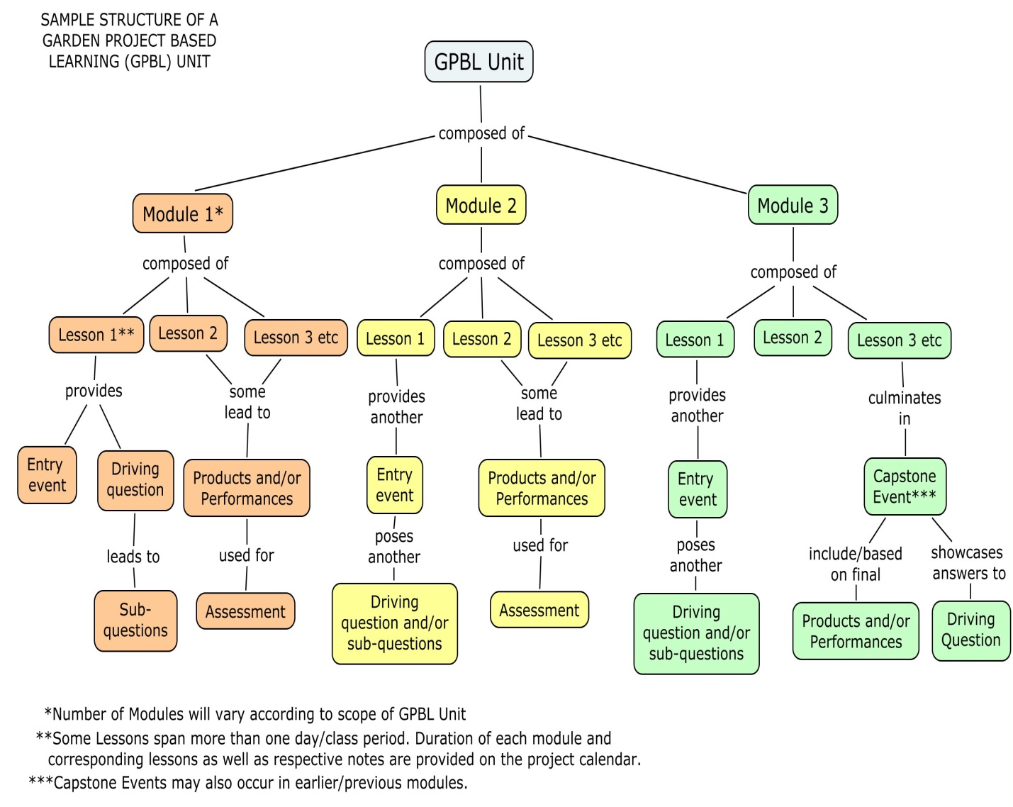

Project Summary
This project is cross-curricular and includes the following subjects: science, math and English Language Arts (reading and writing). When we began this Project there was no fruit growing in the Panther Pride Garden at North Elementary. We hoped that students would want to plant strawberries and grow them so we could add fruit to our produce. This project allows you to grow strawberries in an EarthBox in the classroom. Students can first hand see them grow and take care of them. Students will learn all about strawberries, how to care for them, and what to do with them once harvested. Along the way, as the plants are growing, students will observe their growth and record their observations in their science notebook.
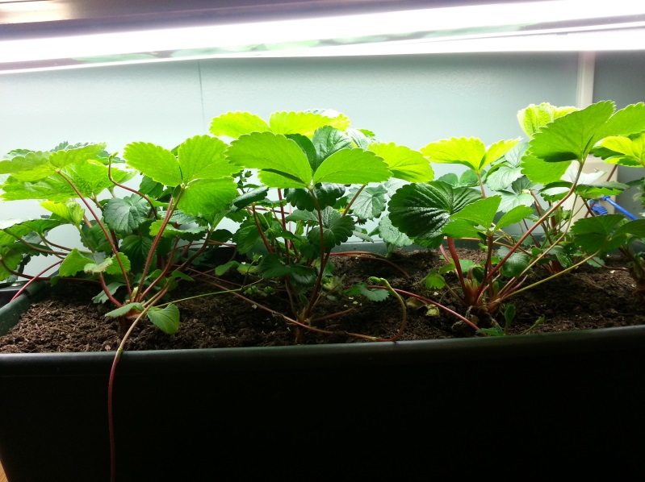
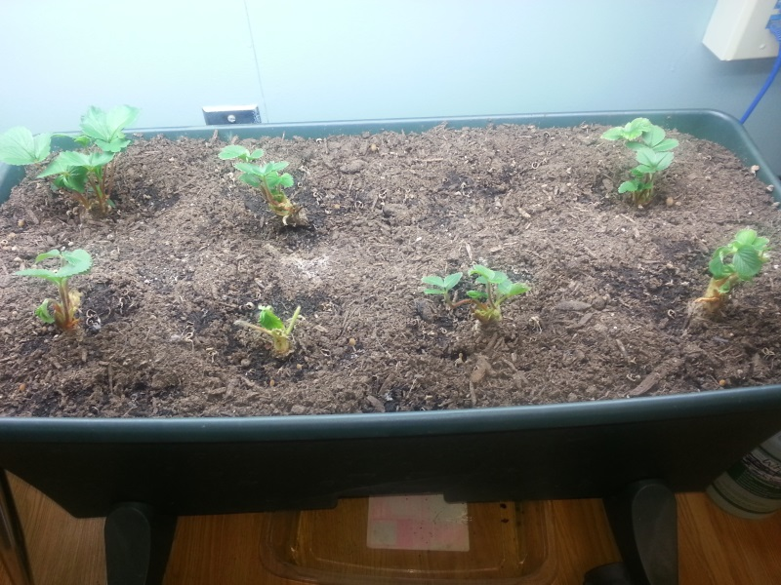

Project Driving Question
How do we best produce and care for strawberries all year long?

Major Products & Performances in Unit
- Science Notebook/Journal
- Planted EarthBox
- Completed data table of plant height with student’s findings/conclusions
- Runner Length – Math Sheet
- Opinion/Persuasive Parent Letter
- Capstone Event Presentation

Resources Needed for Unit
- Strawberry Bare-roots of the Quinault and/or All-Star variety
- ½ inch binder for each student
- Notebook paper for binder
- Bucket
- Hand shovels
- Tape measures and rulers
- Chart Paper and markers
- EarthBox Kit

References Used in Developing Unit
“Plant & Fertilizer Placement Chart.” Copyright EarthBox, 2011. Available from: https://earthbox.com/earthbox-pdf/EB-WEB-INSTRUCTIONS_NEW-2.pdf​
“EarthBox Instruction Manual.” Copyright EarthBox, 2011. Available from: https://earthbox.com/earthbox-pdf/EB-WEB-INSTRUCTIONS_NEW-2.pdf​
Fell, Derek. Vertical Gardening: grow up, not out, for more vegetables and flowers in much less space. New York: Rodale books, 2011. Print.
Garden Harvest Supply. “How to Plant Bare Root Strawberry Plants.” YouTube, 2010. Web.
https://www.youtube.com/watch?v=RJw9GeYocMI
Lener, Elizabeth. “Reuse that Notebook!.” Science and Children v48 n3 Nov. 2010: 56-59. Print.
Mr. Strawberry. “What Are Strawberry Runners? (Stolons).” Strawberry Plants.org: the one stop for everything related to strawberry plants and growing strawberries. May 2010. Web.
Spreading the Passion for Strawberry Plants, 2014 http://strawberryplants.org/2010/05/what-are-strawberry-runners-stolons/ The Weekend Gardener. “Learn How to Properly Plant Bare-Rooted Strawberry Plants.” YouTube. March 2010. Web. https://www.youtube.com/watch?v=_aXP0KIObFA
Penn State Extension. “Handling and Planting Bare Root Plants: How to choose and get the best results from 'bare root' trees, shrubs, and other perennials.” Penn State Extension. College of Natural Agriculture, 2014. Web. http://extension.psu.edu/pests/ipm/pestproblemsolver/perennials-annuals/point-of-purchase/handling.pdf/view/
Rye, J., Forinash, M., Rummel, S., Minor, A., and Scott, H.R. (in press). Garden-based learning: Its just the berries. Science and Children.
University of Nebraska-Lincoln. “Care of Bareroot Plants.” University of Nebraska-Lincoln, 2013. Web. http://byf.unl.edu/Bareroot

Table of Contents
Content
Unit Overview
Standards Targeted Table
Project Calendar
Module 1 Introduction
Lesson 1 - Science Notebooks
Lesson 2 - A Plant’s Needs
Lesson 3 - Entry Event: Just The Berries
Lesson 4 - Preparing EarthBox
Lesson 5 - Root Length
Module 2 Introduction
Lesson 6 - Measuring Runner Lengths
L esson 7 - Parent Letter – Opinion/Persuasive
Lesson 8 - Parent Night Presentation

