Trellising, Roots, or Herbs:
A Colonial Gardening Adventure
4th Grade
Sara Pennington, Elizabeth Stanley, Kevin Kieffer,
Jennifer Mattern, Sonda Cheeseborough, Samantha Little, James Rye

About Garden Project Based Learning (GPBL) Units
Origin of These Units. These Garden Project-Based Learning (GPBL) units originate from instruction that North Elementary School (Morgantown, WV) teachers began providing to students in the Spring of 2011. We launched our school gardening efforts through a “Lowe’s Toolbox for Education” grant and in partnership with the College of Education and Human Services at West Virginia University, Monongalia County Extension Office, Monongalia Technical Education Center, and parents of our students.
When and Where it Happens. In all of these units, GPBL takes place inside (the indoor classroom) and outside (the school garden area “outdoor” classroom). Indoors, students learn through the use of grow lights, heat mats, seed germination and growing containers (e.g., EarthBox®), and vermicomposting bins. Instruction is extended to the outdoors through the use of raised garden beds, in which students directly sow seeds and transplant classroom seedlings (see http://www.thevegetablegarden.info/planting-schedules for USDA growing zones). Students also use low tunnels over the raised beds in order to extend the growing season and protect crops from pests. With permission, garden produce may also be served as part of the school lunch. Cafeteria fruit and vegetable clippings/refuse that is not served to the students can be composted and used to amend the garden soil. Learning can continue throughout summer vacation, where students assist their parents who volunteer to take care of the raised beds (watering, mulching, weeding, trellising, etc.). Produce can be vended at a local farmer’s market.
What’s Essential. First and foremost: You need strong support from the principal, custodial and cafeteria staff, and parents as well as expert assistance from the local extension office, including volunteer master gardeners. Here are a few more essentials:
- Integrate GPBL with core curriculum/standards; do not make it an “add-on.” School gardening is an excellent context for application of the Next Generation Science Standards “Science and Engineering” practices and Common Core Mathematics Practices
- Maintain a small library of gardening text and Internet resources.
- Share knowledge and collaborate on projects.
- Install a fence around and a supply shed close to the outdoor garden; have a close-by water supply, > 6 hours sunlight, and high quality soil (consult County Extension).
- Take safety precautions such as:
  - know what students are allergic to (including bees) and avoid contact; a bee sting to a person with severe allergy (anaphylaxis) requires immediate medication (usually injection of epinephrine) and medical attention (emergency room);
  - wash hands after any gardening activity and keep a first aid kit handy;
  - always install tube covers over fluorescent grow lights;
  - keep water away from electrical outlets/avoid shock hazards;
  - don’t use “chemical” pesticides;
  - use plastic versus glass containers and wear goggles when eye damage may occur
  - supervise students and provide instructions on the use of garden tools (young learners should not use “adult-size” shovels and hoes).

Supplies Commonly Used In Units. (Identification of any product does NOT constitute endorsement).
- Seeds (not treated) or Bare Roots (for strawberries and certain flowers)
- Pots or Sheets of Cells (in which to germinate seeds) and Trays (in which to hold pots)
- Seed Germination Heat Mat
- Craft Sticks for Marking Type/Locations of seeds/transplants
- Grow Lights (e.g., Hydrofarm® T5 Growlight System or cart with lights and place for seed trays)
- Tube Covers/Protectors (you MUST install tube covers over any fluorescent lights)
- Timers (to automatically turn on and off grow lights)
- Containers/kits for Indoor Gardening (e.g., EarthBox®)
- Low Tunnel (you generally need to make these yourself using greenhouse film and bendable hoops, such as PVC pipe or wire that is secured into the ground or in a wooden frame)
- Potting Soil (WonderSoil® or other suitable products also can be used). Note: Soil for planting should be moist enough to form a clump but not gush water when squeezed).
- Measurement Tools (e.g., rulers, moisture/temperature gauges, scale, graduated cylinder/beakers
- Mulch (e.g., partially composted leaves, organic straw, NOT grass from “treated” lawns)
- Wood/frames (NOT treated) and suitable topsoil (check with County Extension) for raised beds
- Horticultural fleece (garden fleece, Agribon®, Reemay®) for insect barrier and frost protection
- Garden Tools (e.g., trowel, shovel, hoe, rake…a mattock for landscaping to install raised beds)
- Compost to Amend Soil (check with County Extension)
How These GPBL Units are Structured. The graphic on the next page illustrates the components of a GPBL unit as well as how these components are interrelated. For units that require the care of garden plants in summer: Students must prepare a caretakers’ guide. They also write a persuasive letter to parents inviting them to a presentation about the garden and to be caretakers (along with their children) during the summer. Development of the guide, letter, and presentation are excellent ways to integrate English/language arts and art as well as apply the science that they have learned throughout their GPBL.
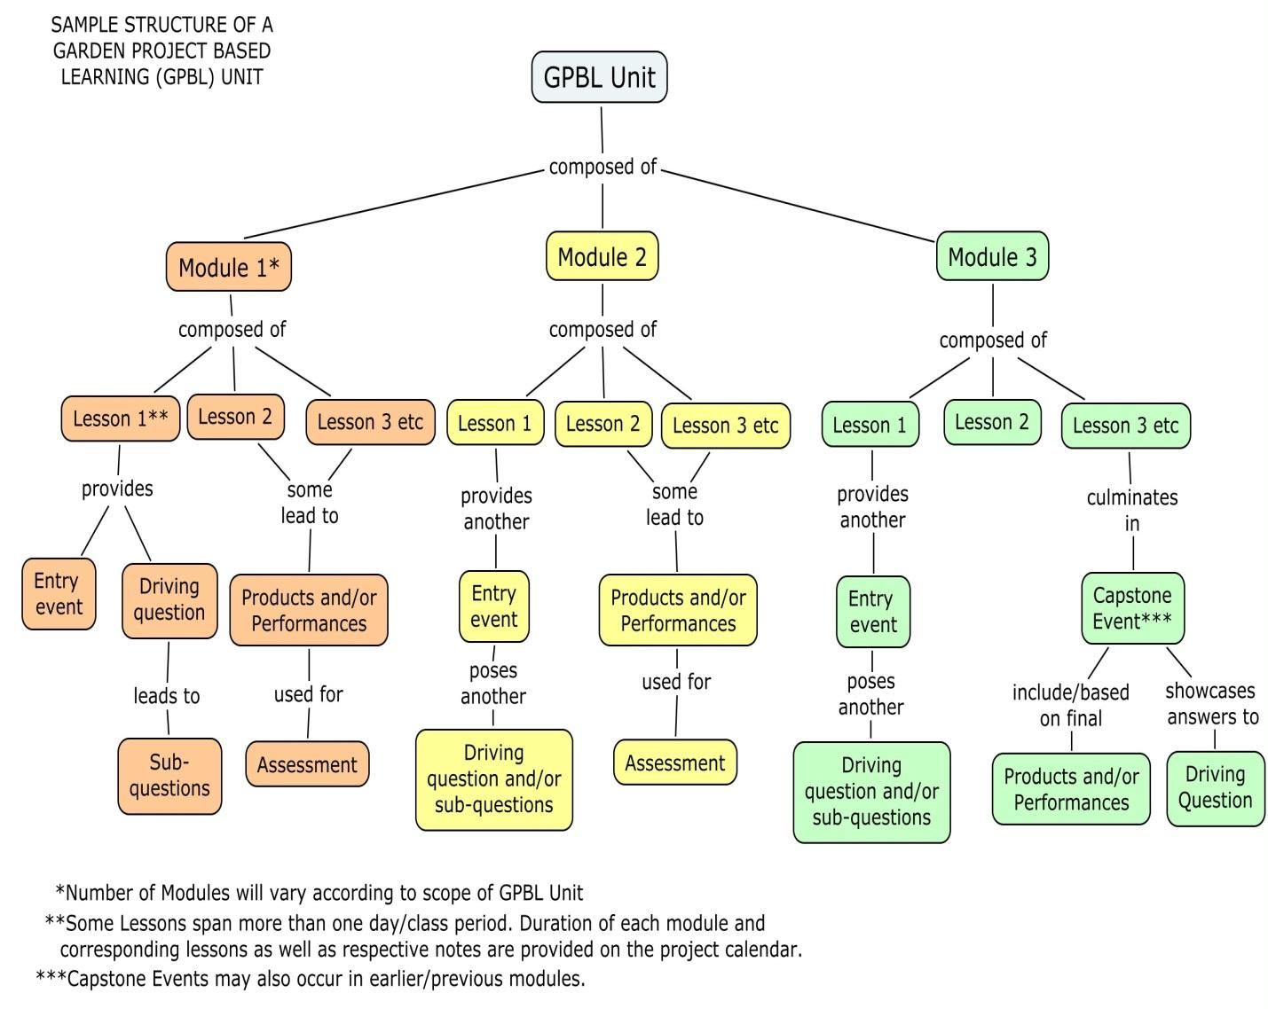

Project Summary
The goal of this Garden Based Project is to be able to plant and produce crops all year long. Students jump start into gardening with a scenario taking them back into time to the Colonial Era. Students will work independently, in pairs, and in small groups throughout the year to learn about the basics of gardening and keeping science notebooks while they grow and harvest a variety of crops. Students will continue to connect their experiences with that of the colonists of the 13 colonies. Next, the students will explore the effect of temperature on gardening. They students will create a scientific test and make a low tunnel to grow winter crops. The students will explore the difference between direct seeding and transplanting. Students will study plants in the classroom and compare them to their gardening experience to the first unit. As the year comes to a close, the students will use their knowledge to determine what plants the colonists would grow during the summer months. The students will use their research to create a care-takers plan and video to teach their families how to care for the plants during the summer.

Project Driving Question
Which plants will be the most successful within a classroom earthbox (trellising, root, or herb)?

Resources Needed for Unit
EarthBox: http://earthbox.com/

References Used in Developing Unit
Pranis, Eve, and Jack Hale. GrowLab: A Complete Guide to Gardening in the Classroom. Burlington, VT: National Gardening Association, 2006. Print.

Title | Introduction to Gardening in the Classroom
Overview | - The goal of this lesson is to introduce students to root, trellising, and herb crops and pose the driving question: Which will be the most successful within a classroom Earthbox?  - Throughout the modules, the students will be provided with opportunities to learn about the different crops and to determine which they feel will be the most successful within our classroom EarthBox.  - Duration: One week
Standards | ELA.4.W.C9.2 Write informative/explanatory texts to examine a topic and convey ideas and information clearly. Introduce a topic clearly and group related information in paragraphs and sections; include formatting (e.g.,  headings), illustrations, and multimedia when useful to aiding comprehension. Develop the topic with facts, definitions, concrete details, quotations, or other  information and examples related to the topic. Link ideas within categories of information using words and phrases (e.g., another, for example, also, because). Use precise language and domain-specific vocabulary to inform about or explain the topic. Provide a concluding statement or section related to the information or explanation presented.
Materials/Advance Preparation Needed | - Provided Scenario  - Computers, Internet  - Paper/pencils  Advanced Preperations:  - Make copies of Welcome Home Scenario  - Check out computer lab  - Helpful websites for researching:
Procedures/Steps:  (Emphasis on students making inquiry, e.g., posing questions/problems and working towards answers and solutions) | Introduction: The students will be introduced to a provided scenario based on colonial settlers. Pass out provided scenarios and read together as a class.  Lesson: Within the scenario they will learn that they are settlers who have reached the West. Their Aunt Bertha was too old and frail to make the trip with them so they will need to write letters to her to keep her updated.  Next, the students will take part in a KWL chart activity. The teacher will pose the question, “What do we already know about the different kinds of crops that we can plant in our EarthBox (trellising, herb, and root). Also fill in “want to know” together as a class.  Each student will research the different types of crops that we can potentially grow in our classroom Earthbox. They will then need to to determine which crops would be most successful within the Earthbox  Allow students time to research information and take notes. Tell them that tomorrow they will be writing a persuasive letter using the information that they have found so they will need to keep their materials in a safe place.  Closure: A discussion of root, trellising, and herb crops will be had. Fill in the final part of the KWL chart together as a class.
Assessment (What will be the evidence of student learning?) | The students will use the information that they have researched to then write a persuasive letter to Aunt Bertha as to which kind crops they think will be the most successful within the Earthbox. The students will be assessed using a teacher created rubric titled, “Letter to Aunt Berta Rubric” (see attached).

Welcome Home (Scenario)
The year is 1822. You just spent the last few months traveling to reach your destiny in the West. You left Independence, Missouri in the late months of spring, and you have now arrived at a plot of land in the West that you and your wagon company have decided to call home. The land is flat, the grass is green, and the sky is the brightest blue you have ever laid your eyes on. You are not the only wagon company that has decided to make this great span of land your home. There are various other settlements that are close by that you will be able to buy from and trade with.
You have various items that you have brought from Independence, some you have traded for along the way, and your company is eager to begin setting up a settlement. Among your belongings, you find the letter from your Great Aunt Bertha, who wanted so badly to join you on this trip west, but due to her old age, decided it would be best to stay back in Missouri. You did make her a promise to keep a journal of your adventures once you reached your settlement, and you aim to keep that promise. You remove your journal from the covered wagon, find a quill to write with, take a deep breath of the fresh air, and start your first journal entry. Welcome home.

