Kindergarten Plants a Garden
Grade Level: Kindergarten
Authors: Laura VanHorn and Dr. Melissa Luna

About These Units
Origin of These Units. These Garden Project-Based Learning (GPBL) units originate from instruction that North Elementary School (Morgantown, WV) teachers began providing to students in the Spring of 2011. We launched our school gardening efforts through a “Lowe’s Toolbox for Education” grant and in partnership with the College of Education and Human Services at West Virginia University, Monongalia County Extension Office, Monongalia Technical Education Center, and parents of our students.
When and Where it Happens. In all of these units, GPBL takes place inside (the indoor classroom) and outside (the school garden area “outdoor” classroom). Indoors, students learn through the use of grow lights, heat mats, seed germination and growing containers (e.g., EarthBox®), and vermicomposting bins. Instruction is extended to the outdoors through the use of raised garden beds, in which students directly sow seeds and transplant classroom seedlings (see http://www.thevegetablegarden.info/planting-schedules for USDA growing zones). Students also use low tunnels over the raised beds in order to extend the growing season and protect crops from pests. With permission, garden produce may also be served as part of the school lunch. Cafeteria fruit and vegetable clippings/refuse that is not served to the students can be composted and used to amend the garden soil. Learning can continue throughout summer vacation, where students assist their parents who volunteer to take care of the raised beds (watering, mulching, weeding, trellising, etc.). Produce can be vended at a local farmer’s market.
What’s Essential. First and foremost: You need strong support from the principal, custodial and cafeteria staff, and parents as well as expert assistance from the local extension office, including volunteer master gardeners. Here are a few more essentials:
- Integrate GPBL with core curriculum/standards; do not make it an “add-on.” School gardening is an excellent context for application of the Next Generation Science Standards “Science and Engineering” practices and Common Core Mathematics Practices
- Maintain a small library of gardening text and Internet resources.
- Share knowledge and collaborate on projects.
- Install a fence around and a supply shed close to the outdoor garden; have a close-by water supply, > 6 hours sunlight, and high quality soil (consult County Extension).
- Take safety precautions such as:
  - know what students are allergic to (including bees) and avoid contact; a bee sting to a person with severe allergy (anaphylaxis) requires immediate medication (usually injection of epinephrine) and medical attention (emergency room);

  - wash hands after any gardening activity and keep a first aid kit handy;
  - always install tube covers over fluorescent grow lights;
  - keep water away from electrical outlets/avoid shock hazards;
  - don’t use “chemical” pesticides;
  - use plastic versus glass containers and wear goggles when eye damage may occur
  - supervise students and provide instructions on the use of garden tools (young learners should not use “adult-size” shovels and hoes).

Supplies Commonly Used In Units. (Identification of any product does NOT constitute endorsement).
- Seeds (not treated) or Bare Roots (for strawberries and certain flowers)
- Pots or Sheets of Cells (in which to germinate seeds) and Trays (in which to hold pots)
- Seed Germination Heat Mat
- Craft Sticks for Marking Type/Locations of seeds/transplants
- Grow Lights (e.g., Hydrofarm® T5 Growlight System or cart with lights and place for seed trays)
- Tube Covers/Protectors (you MUST install tube covers over any fluorescent lights) Timers (to automatically turn on and off grow lights)
- Containers/kits for Indoor Gardening (e.g., EarthBox®)
- Low Tunnel (you generally need to make these yourself using greenhouse film and bendable hoops, such as PVC pipe or wire that is secured into the ground or in a wooden frame)
- Potting Soil (WonderSoil® or other suitable products also can be used). Note: Soil for planting should be moist enough to form a clump but not gush water when squeezed).
- Measurement Tools (e.g., rulers, moisture/temperature gauges, scale, graduated cylinder/beakers
- Mulch (e.g., partially composted leaves, organic straw, NOT grass from “treated” lawns)
- Wood/frames (NOT treated) and suitable topsoil (check with County Extension) for raised beds
- Horticultural fleece (garden fleece, Agribon®, Reemay®) for insect barrier and frost protection
- Garden Tools (e.g., trowel, shovel, hoe, rake…a mattock for landscaping to install raised beds)
- Compost to Amend Soil (check with County Extension)
How These GPBL Units are Structured. The graphic on the next page illustrates the components of a GPBL unit as well as how these components are interrelated. For units that require the care of garden plants in summer: Students must prepare a caretakers’ guide. They also write a persuasive letter to parents inviting them to a presentation about the garden and to be caretakers (along with their children) during the summer. Development of the guide, letter, and presentation are excellent ways to integrate English/language arts and art as well as apply the science that they have learned throughout their GPBL.

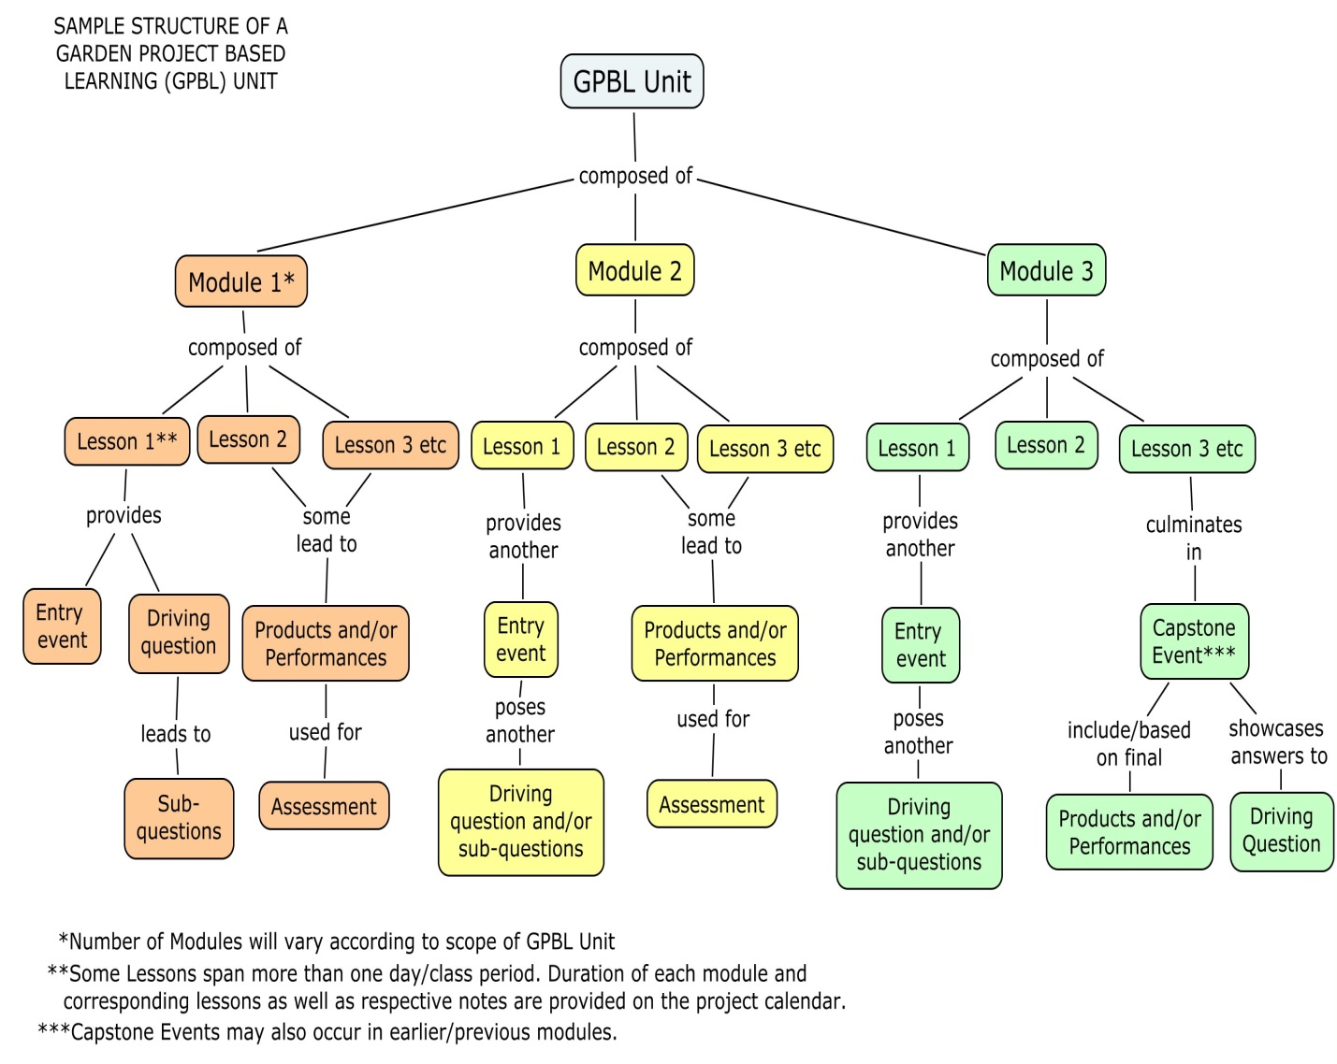

Project Summary
Students, through questioning, survey, and research, will investigate what they can grow in the garden and when and how it should be planted. These units are meant to be a blueprint for an introduction to gardening with kindergarten. Students determine what and when to plant. It includes lessons on vermicomposting (worm farming) and a final project presentation.

Project Driving Question(s)
How can we best grow our favorite vegetables in our school’s garden?
Sub questions: What is your favorite vegetable? How do you know if something is a vegetable? What vegetables can we plant here in (your state)? How does weather affect what and when we plant?

Major Products & Performances in Unit

Graph which drives planning and instruction for garden projects for the year
Garden indoor and/or outdoor
Functioning vermicomposting unit
Final presentation

Materials Needed for Unit
Module 1  Lesson 1 | Chart paper/dry erase board for brainstorming  Large sheet of butcher paper  3”x 3” white construction paper (3 per student)  Crayons/markers  Glue sticks  Letter to families explaining project/homework assignment (Appendix A) Internet/Interactive Whiteboard (research in advance the vegetables that prove most popular in class survey, also have resources previewed to help in determining the difference between a fruit and a vegetable)  Variety print resources (use your school library, local extension agent, local Farmer’s market, etc.)
Module 1  Lesson 2 | Graph completed in Lesson 1  Family response cards  Internet/Interactive whiteboard (research in advance the vegetables that prove most popular in class survey)  Variety print resources (use your school library, local extension agent, local Farmer’s market, etc.)  Science journals (optional)
Module 1  Lesson 3 | Computer lab or mobile laptops  Science journals  Pencils/crayons  Students divided into predetermined groups of 4  Chart paper/markers  Chicken wire  Straw  Soil  Seed potatoes
Module 2  Lesson 1 | Vermicomposting unit (worm bin)  Newspaper  Popsicle sticks  Science journals  Pencils/crayons
Module 2  Lesson 2 | Vermicomposting unit (worm bin)  Newspaper  Popsicle sticks  Board/chart paper  Note cares/paper (1 per group)  Possible additional supplies (based on inquiry questions) magnifying glasses, flashlights, small boxes or paper to form boxes
Module 3  Lesson 1 | Board/chart paper  Science journals  Access to folder of stored digital photos of gardening projects during year  Access to computer lab or class set of mobile laptops  PowerPoint or similar presentation software

Resources Needed for Unit
Module 1  Lesson 1 | http://gigapan.com/gigapans?query=north+garden+gbl
Module 1  Lesson 3 | http://www.backyardfarmingconnection.com/2013/04/potato-towers.html  http://www.youtube.com/watch?v=tyt3GuoYJ7k
Module 2  Lesson 1 | Wonderful Worms by Linda Glaser

Table of Contents

Content | Page
Project Overview
Standards Targeted
Module 1 Overview
Module 1 Lesson 1
Module 1 Lesson 2
Module 1 Lesson 3
Module 2 Overview
Module 2 Lesson 1
Module 2 Lesson 2
Module 3 Overview
Module 3 Lesson 1
Appendix A

