Title/Focus | Preparing EarthBox and Planting strawberries (2 days)
Overview | Students will learn the proper steps of putting an EarthBox together and how the unit functions. Students will then put the EarthBox together and prepare it for planting. Students will learn how to plant a bare-root and the class will plant 8 bare-root strawberries in the EarthBox.
Standards | ELA.2.R.C2.4: determine the meaning of words and phrases in informational text relevant to grade 2 topic or subject area.  ELA.2.R.C3.3: explain how specific images contribute to and clarify an informational text.  ELA.2.R.C1.6: describe the connection between a series of scientific ideas or steps in technical procedures in an informational text.  ETS1-2: Develop a simple sketch, drawing, or physical model to illustrate how the shape of an object helps it function as needed to solve a given problem.  WE.1.1.02: describe the effects of healthy and less healthy foods on the body
Materials/Advance Preparation Needed | Materials  - Chart paper & markers  - EarthBox (fertilizer and dolomite)  - bare root strawberries (Variety: Quinault and All Star)  - soil  - water  - Bucket/mix soil and water  - Hand shovel for kids  - Garden Words word search (included)  - Handling and planting “Bare Root” Plants Handout (included)  Advanced Preparation:  - Have EarthBox instruction manual with copies.  - Have a chart paper to write steps on.  - Have all materials set up in the areas the lesson will take place.  - Find and have videos ready from youtube (listed below).  - Soak the strawberry roots in water 15 minutes prior to planting and cut off the bottom quarter of the root system to help the plants grow faster.
Procedures/Steps  (Emphasis on students making inquiry, e.g., posing questions/ problems and working towards answers and solutions) | Driving Question: How does an EarthBox function?  Day 1  Introduction: Show students an empty EarthBox and have a discussion about how it works. (Ask students how they think it works and why they are good to use indoors to grow plants.) Allow students to think-pair-share with these questions. Watch video from youtube: EarthBox & self-watering container gardening  Lesson: Using copies of the EarthBox instructional manual have students read it in small groups and discuss the steps to take to plant in the EarthBox. Have students share whole class the steps to take to prepare the EarthBox and plant in it. Make a list of the steps on chart paper. Take completed chart paper and go to the area where EarthBox will be prepared for planting. Students will read each step in preparing the EarthBox and then the class will complete the steps. Students will record each step in their science notebook as it is completed. Have a discussion with class explaining the need of dolomite and fertilizer that is added to the top part of the soil. This discussion needs to include the human body and what the body needs to grow. Help students make a comparison of what soil needs to help plants grow and of what a human body needs to grow. EarthBox will be used on Day 2 to plant the bare-root strawberries.  Closure/Assessment: Have students draw and label a picture and write down what they learned from today’s lesson (in science notebook) to check for understanding about the EarthBox and how it works.  Day 2: ***Do this if you choose to not do the Root Length Lesson***  Introduction: Watch the following videos from youtube: Learn How to Properly Plant Bare-Rooted Strawberry Plants and How to Plant Bare Root Strawberry Plants.  Lesson: Have a class discussion about how we should plant the bare-roots. Make sure to ask about the crown and what happens if you bury the crown in the soil. Plant 8 bare-root strawberries with the help of the students. Follow the 8 seedlings diagram on the Plant & Fertilizer Placement Chart on the EarthBox instruction manual.  - To help keep all students engaged we created a word search (free puzzle maker online) using garden words and vocabulary words learned in previous lessons.  Closure/Assessment: 1) Have students draw and label the EarthBox with newly planted strawberries in their science notebook. 2) Have students write the proper way to plant a bare-root strawberry.
Assessment (What will be the evidence of student learning?) | Evidence of student learning: the drawing/sketch of the EarthBox and explanation of how it functions & explanation of proper way to plant a bare-root.
***Students will now use the planted EarthBox to complete weekly observations (pictures and writing). These observations will be recorded in their Science Notebooks (make sure they are dated). These observations will be used as an assessment to measure students’ growth involving: vocabulary, length of writing, evidence of claims, week-to-week comparisons of plant growth, and detailed observations.
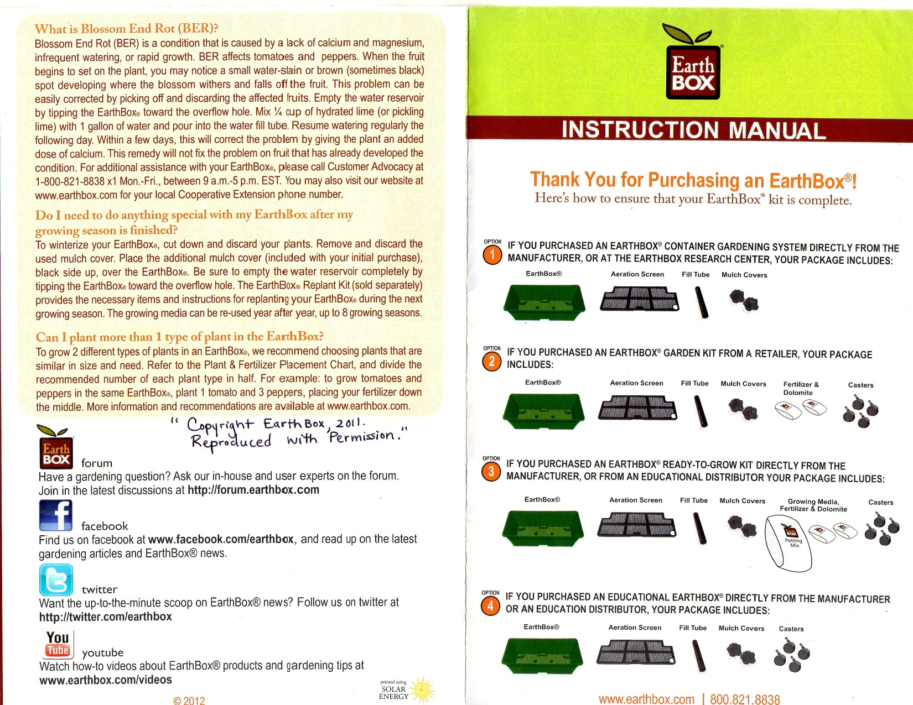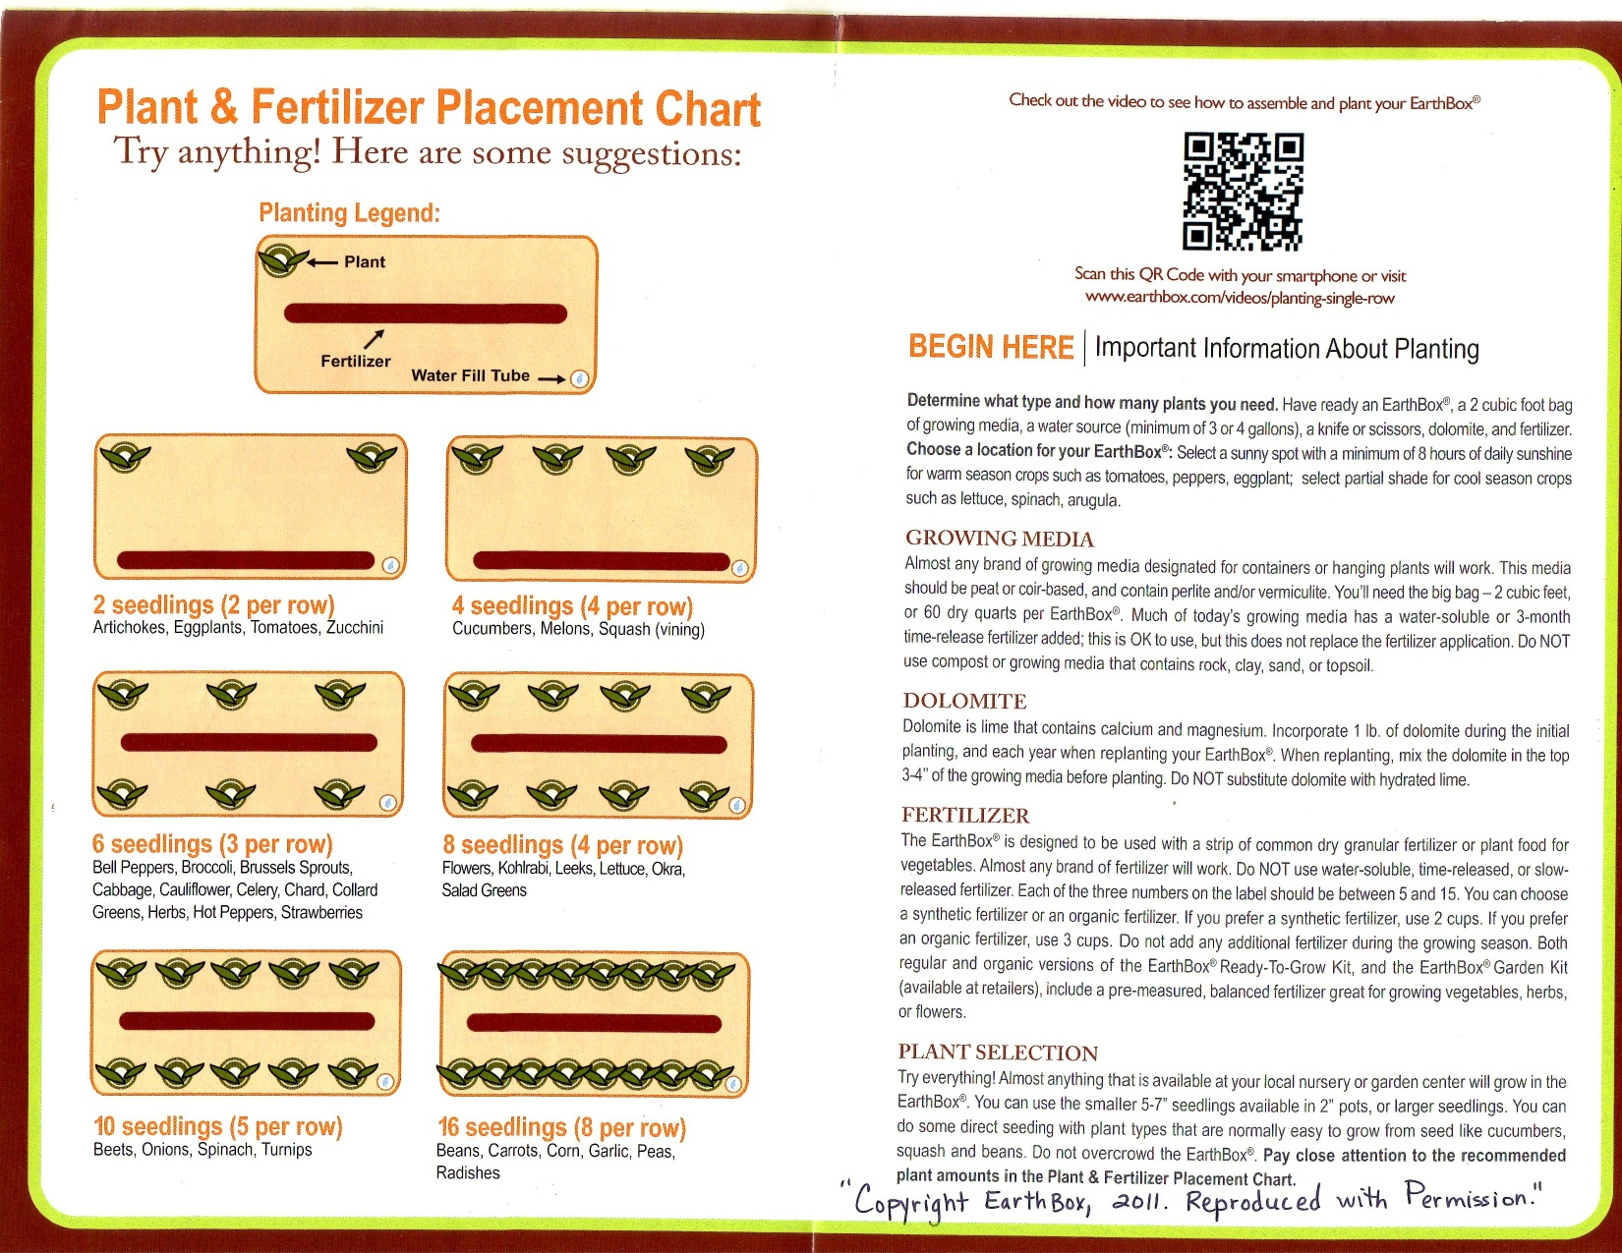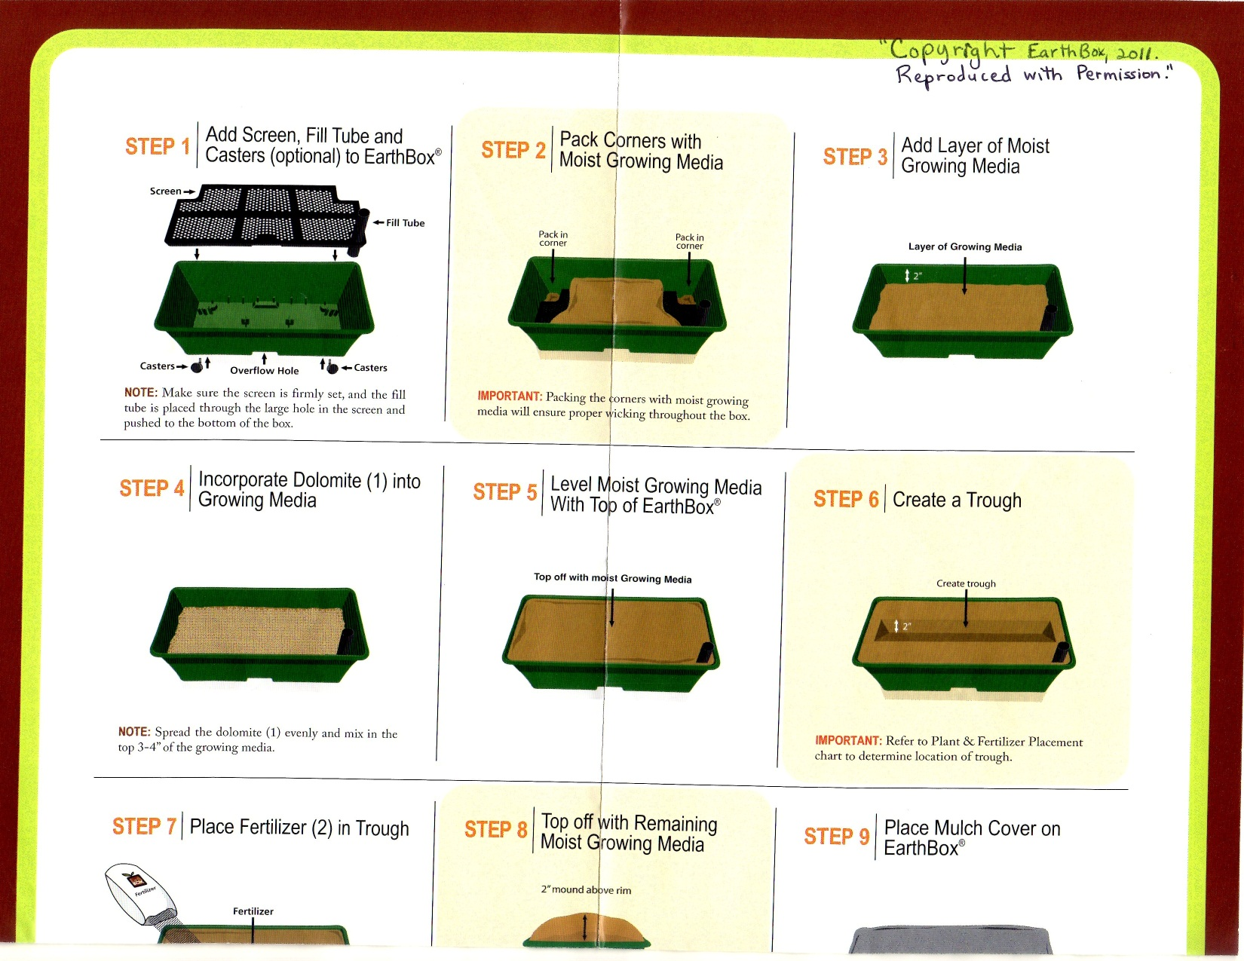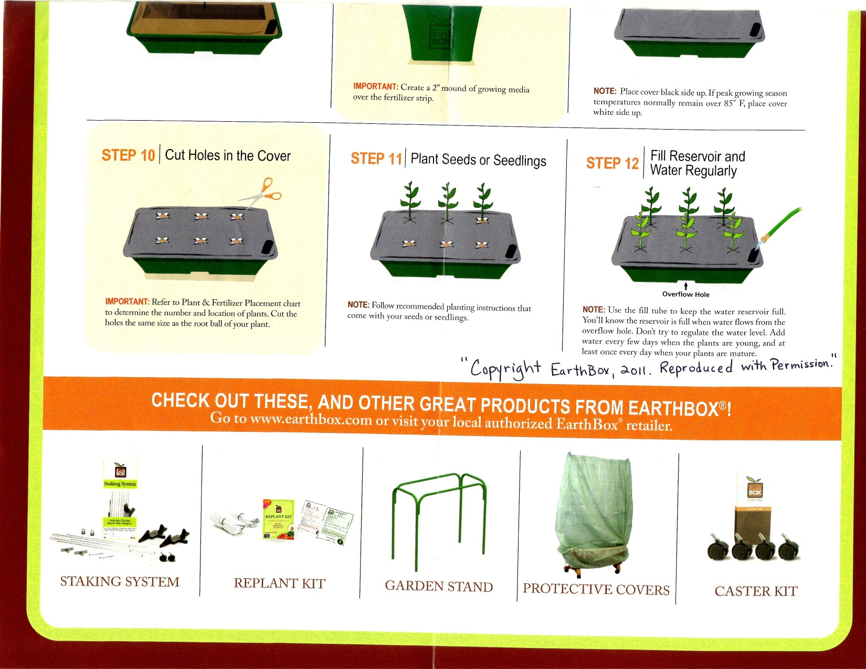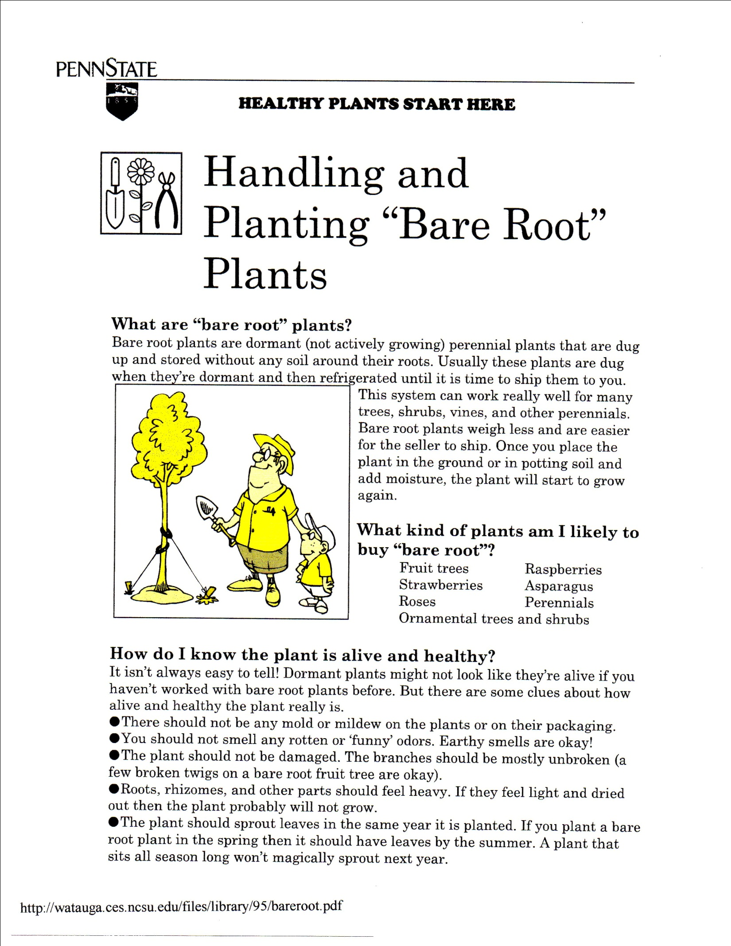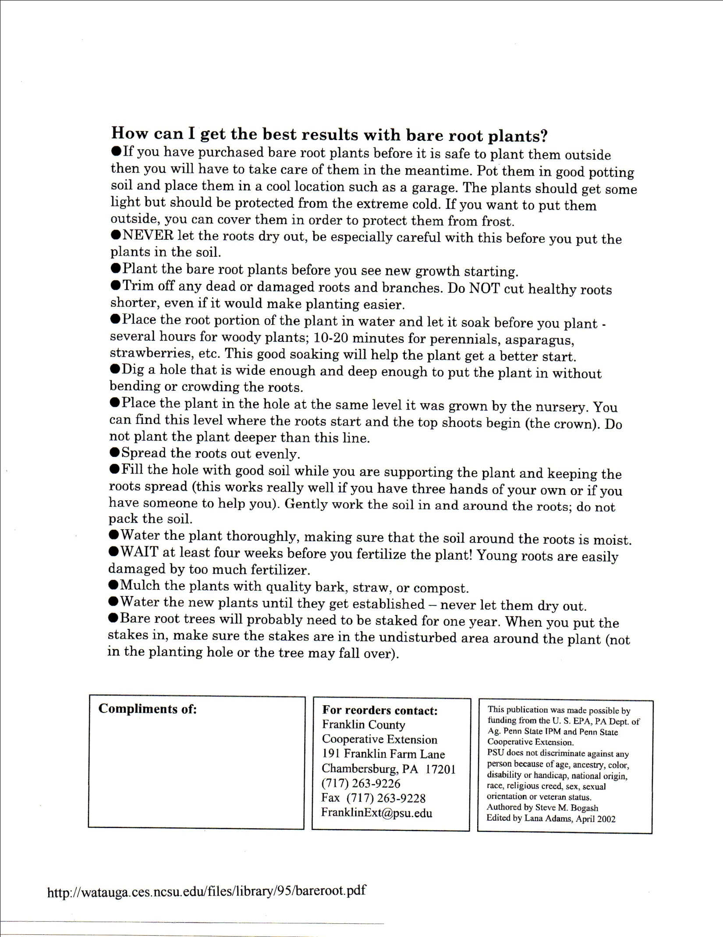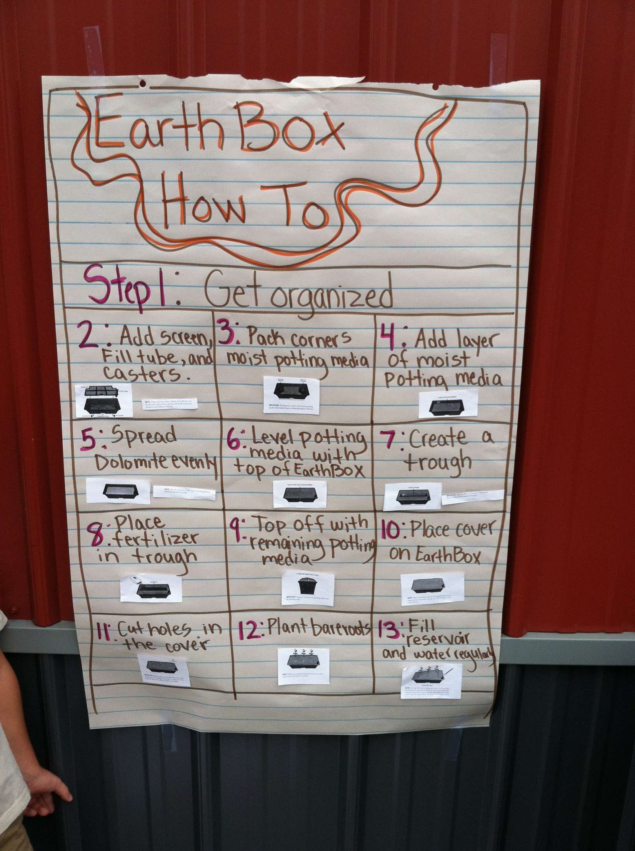
Anchor Chart Example – Mrs. Minor’s Class

