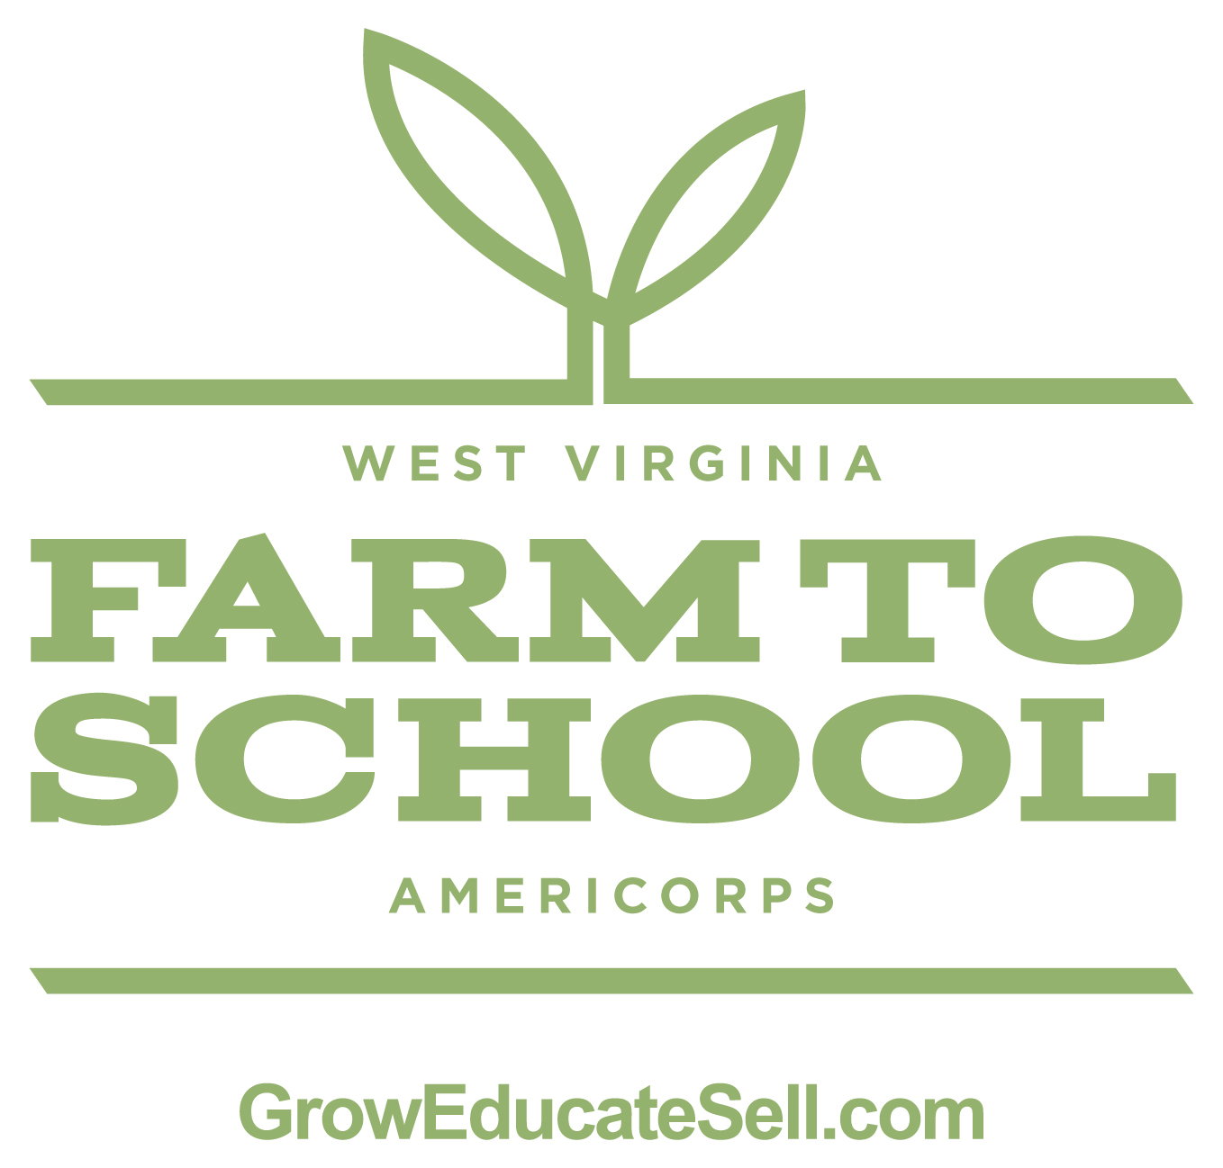

FOR IMMEDIATE RELEASE

Contact:

The WVDE's Farm to School Program Has Set Roots Across the State

CHARLESTON, W.Va. – Students across Kanawha County will roll up their sleeves and dig into fresh farm food on Wednesday, Oct. 16. This event is part of the West Virginia Department of Education's (WVDE) Farm to School (F2S) program. The WVDE F2S program has been in place for three years with participation from 30 county school systems.
McKinley Middle School in St. Albans, West Virginia will serve as the host school for the countywide Farm to School Celebration. Media is invited to attend the Farm to School lunch from 12:15 p.m. to 1 p.m. on Wednesday, Oct. 16. Students, local farmers, county school leaders and others will take part in the event.
"The WVDE Office of Child Nutrition is encouraging all of our county school systems to share their Farm to School success stories," said Richard Goff, Office of Child Nutrition executive director. "When counties purchase local products from farmers, the food served in our schools is not only fresher, but the local dollars stay in the community. The economic and community development opportunities with the farm to school initiative in West Virginia are limitless and the impact is real."
Three years ago the WVDE hired a full-time F2S coordinator to work around the state, provided grants to agricultural education programs to enhance onsite growing projects, funded student farmers through entrepreneurial grants, and provided incentives for counties to purchase local products. The success of the program is based on partnerships with county school system food service directors, the West Virginia Department of Agriculture, the West Virginia University Cooperative Extension-Small Farm Center, the New Appalachia Farm and Research Center, and Collaborative for 21st Century Appalachia.
"After years of building the foundation of F2S in West Virginia, the initiative is taking off statewide," added Goff. "Now food service directors have confidence that there will be product available for purchase and farmers trust that there is a true market for their product."

F2S Quick Facts
- In 2012 - 2013, approximately $350,000 were spent on local products in West Virginia schools
- 30 counties purchased local foods for schools last year
- 13 agricultural education programs have been funded
- 16 schools were funded with $2,000 start-up grants from United States Department of Agriculture Team Nutrition funds
- More than 60 students were funded with entrepreneurial grants to start their own farming business
- The WVDE will be sponsoring 10 AmeriCorps members with funding from the Benedum Foundation to help counties around the state with their farm to school efforts
- Three regional AmeriCorps will also be starting to build capacity in counties that have not been able to connect with local farmers.
Goff added that Kanawha County Schools as well as other county food service programs deserve kudos for getting fresh farm food on the table. Kanawha County's F2S program has been especially successful and is growing. Diane Miller, the food service director, has been networking with more farmers every growing season. Some schools are receiving almost 25 percent of their weekly produce needs for their garden bars from the F2S program.
For more information, contact (insert contact info here).
Be sure to follow us on Facebook, Twitter and Google.

-30-

The Farm to School Community Development Group is a collaboration of West Virginia partners including: West Virginia Department of Education, West Virginia Department of Agriculture, West Virginia University Cooperative Extension – Small Farm Center, New Appalachian Farm and Research Center, and Collaborative for 21st Century Appalachia. The group is working toward two primary goals: 1. Grow the next generation of farmers in West Virginia and 2. Increase the amount of local foods served in our schools.

