Trellising, Roots, or Herbs:
A Colonial Gardening Adventure
Spring Module
Squash, Corn, and Radishes
4th Grade
Sara Pennington, Elizabeth Stanley, Kevin Kieffer,
Jennifer Mattern, Sonda Cheeseborough, Samantha Little, James Rye

Driving Question(s)
Which plants will be most successful within our classroom EarthBox (trellising, root, or herb)
Given specific crops, which will be the most successful in the spring months?
How are plants dependent on one another?
Overview
During this module, students will be planting a Three Sisters Garden which consists of beans, corn, and squash. Throughout the module they will learn about the Native American influence. The students will participate in art, music, and physical education lessons. They will create a Caretaker’s Guide as well as a brochure at the end of this module. This will be used to share with parents so that in hopes that they will come help take care of the garden over the summer months.
Major Products & Performances
Group: | Baseball Game  Brochure  Caretaker’s Guide  Three SIsters Garden
Individual: | Planting Seeds  Math Activities  Journaling  Making predictions/observations  Researching  Art Project  Physical Education

Teacher Background
About the Plant(s)
Squash: http://www.almanac.com/plant/squash-zucchini
Corn: http://www.almanac.com/plant/corn
Radishes: http://www.almanac.com/plant/radishes

Title | Lesson One: Entry Event - Three Sisters Garden
Overview | The students will be introduced to a Three Sisters Garden today. They will read the spring new scenario and make predictions about this type of garden. They will also draw/label a Three Sisters Garden.
Standards | SS.4.G.2 document the effects of and explain how people adapted to geographic factors (e.g., climate, mountains, bodies of water, etc.) on the following:  - transportation routes  - settlement patterns and population density  - culture (e.g., jobs, food, clothing, shelter, religion, government, etc.)  - interactions with others (local and national).  ELA.4.R.C2.4 determine the meaning of general academic and domain-specific words or phrases in an informational text relevant to a grade 4 topic or subject area.
Materials/Advance Preparation Needed | Materials:  - Whiteboard or chalkboard  - Paper  - Pencils/Crayons  Advanced Preparations:  - Have paper ready for students to draw and label their diagrams.
Procedures/Steps:  (Emphasis on students making inquiry, e.g., posing questions/problems and working towards answers and solutions) | Introduction: Tell the students that today we will be learning all about a “Three Sisters Garden”. Ask them to make predictions about what a Three Sisters Garden might be.  Lesson: Explain to the students what a Three Sisters Garden is and how companion planting works.  - A Three Sisters Garden is a Native American form of gardening. Corn, beans, and squash are all grown together in one hole, on one mound. As plants grow, they form a living community: an ecosystem.  - The three plants rely on each other for food, support, shade and protection.  - Students will research what role each plant plays and construct an explanation for how the plants are interdependent.  Closure Ask students to make predictions as to what kind of plants they think our three sister plants are (trellising, root, or herb). Also ask them if they think that a three sisters garden could be successful in our classroom Earthbox or do we think that this needs to be planted outdoors?

Garden in Bloom

So it turns out…winter is rough in the West. You made it through with the crops the crops that you planted, but just barely. Tensions are high in your settlement, and people are hungry. Spring is right around the corner, the snow has melted, and flowers are starting to bloom. You are exhausted, but you know you have to get your spring garden ready as soon as possible.
While preparing your garden, you notice something out of the corner of your eye. Native Americans have entered your settlement. Now, you’ve heard some stories about Native Americans on your journey to the West. Turns out, they don’t always get along with colonists. However, this group of natives looks as if they are here for peaceful reasons. They approach you with what looks like seeds. Have they come to help you with your spring garden? They’ve lived on this land much longer than you have, so they probably know a thing or two about planting for this area.
You take the seeds they have given you and realize you have seen these before. You notice that they have given you corn kernels, squash seeds, and more beans to grow. You’ve heard of this before. Your Great Aunt Bertha used to plant these things together in the spring and referred to them as the three sisters. You thank the Native Americans for their generosity, and begin planting for spring.

Title | Lesson Two: The Sun’s Daughter Read Aloud
Overview | The teacher will be reading the story “The Sun’s Daughter,” by Pat Sherman. This story deals with the idea of the three sister’s garden, but as an Iroquois legend. After finishing the story, students will create a story map of the main idea and supporting details.
Standards | ELA.4.R.C1.2 determine a theme of a story, drama or poem from details in the literary text; summarize the text  ELA.4.R.C1.1 refer to details and examples in a literary text when explaining what the text says explicitly and when drawing inferences from the text
Materials/Advance Preparation Needed | Materials:  - The Sun’s Daughter by Pat Sherman  - Story Map sheet for each student  - Coloring utensils  Advanced Preparation:  - Students must know how to identify the theme of a story.  - Students must be able to draw inferences.  - Story map must be copied and prepared for students.
Procedures/Steps:  (Emphasis on students making inquiry, e.g., posing questions/problems and working towards answers and solutions) | Introduction: The teacher will begin by having the students come to a whole group teaching area, if available. Show the cover of the book to the students and ask them what they think it may be about. After taking student responses, ask them whether they think this book will be fiction or nonfiction. How do they know?  Lesson: The teacher will read the book aloud to the students, stopping to ask guiding questions as the teacher reads. Guide students to connecting what the story is telling to what they are doing in their classroom garden with the three crops.  Closure: When the book is finished, the students will work on creating a story map at their desks that covers the major events in the story.
Assessment (What will be the evidence of student learning?) | Students will turn in their completed story map. The teacher will check these to see if the students were able to find the major events of the story.

Title | Lesson Three: Native American Lesson
Overview | Students will learn about what crops the Iroquois people traded with settlers. Students will research the crops and develop plans for how to harvest the crops in their own garden (e.g., corn, squash, green beans, lima beans, kidney beans, pumpkin, melons).
Standards | ELA.4.W.C11.1 Conduct short research projects that build knowledge through investigation of different aspects of a topic.  ELA.4.L.C15.1 Demonstrate command of the conventions of Objective English grammar and usage when writing or speaking. Use relative pronouns (who, whose, whom, which, that) and relative adverbs (where, when, why). Form and use the progressive (e.g.,I was walking; I am walking; I will be walking) verb tenses. Use modal  auxiliaries (e.g., can, may, must) to convey various conditions. Order  adjectives within sentences according to conventional patterns (e.g.,  a small red bag rather than a red small bag). Form and use prepositional phrases. Produce complete sentences, recognizing and correcting inappropriate fragments and run-ons. Correctly use frequently confused words (e.g., to, too, two; there, their).  ELA.4.W.C12.1 Write routinely over extended time frames (time for research, reflection, and revision) and shorter time frames (a single sitting or a day or two) for a range of discipline-specific tasks, purposes, and audiences.
Materials/Advance Preparation Needed | Materials:  - Laptops  - Notebook paper  - Pencils  Advanced Preparations:  - Reserve class set of laptops for research.
Procedures/Steps:  (Emphasis on students making inquiry, e.g., posing questions/problems and working towards answers and solutions) | Introduction: Ask the class what the know about the Iroquois people using a KWL chart. Tell the class that they will be researching the crops that the Iroquois people traditionally grew (e.g., squash, green beans, lima beans, kindey beans, pumpkins, and melons). Complete the “K” and “W” portion of the KWL chart.  Lesson: Allow students to work in partners (assigned or chosen by students). Pass out laptops to each group of partners. Students will record how the plants were harvested.  Closure: After students have completed their research, have a class discussion about what they learned. Complete the “L” portion of the KWL chart. Next, have students get out their science journals. Have students write about the crops that the Iroquois people grew as well as how they grew them. Students must also describe they steps they would have to take in order to grow these crops.
Assessment (What will be the evidence of student learning?) | Students will write in their science journals about the crops that the Iroquois people grew. They will also need to list and explain directions for how they can harvest the same crops the Iroquois harvested.

Title | Lesson Five: Planting Three Sisters Garden (Using Earthbox)
Overview | The students will setting up their classroom Earthbox today. They will be able to make predictions about how to do this successfully. They will need to find the area of the Earth Box in order to divide the box into plots so that the students can plant their seeds in small groups. They will also need to research how deep to make the holes to plant the seeds and measure these holes when planting.
Standards | 4 LS1-1: Construct an argument that plants and animals have internal and external structures that function to support survival, growth, behavior, and reproduction.  M.4.MD.4 Make a line plot to display a data set of measurements in fractions of a unit (1/2, 1/4, 1/8). Solve problems involving addition and subtraction of fractions by using information presented in line plots. For example, from a line plot find and interpret the difference in length between the longest and shortest specimens in an insect collection.  M.4.MD.1 Know relative sizes of measurement units within one system of units including km, m, cm; kg, g; lb, oz.; l, ml; hr, min, sec. Within a single system of measurement, express measurements in a larger unit in terms of a smaller unit. Record measurement equivalents in a two column table. For example, know that 1 ft is 12 times as long as 1 in. Express the length of a 4 ft snake as 48 in. Generate a conversion table for feet and inches listing the number pairs (1, 12), (2, 24), (3, 36).M.4.MD.3 Apply the area and perimeter formulas for rectangles in real world and mathematical problems. For example, find the width of a rectangular room given the area of the flooring and the length, by viewing the area formula as a multiplication equation with an unknown factor. Represent and interpret data.
Materials/Advance Preparation Needed | Materials:  - Measuring tape and rulers  - String and tape  - Earth box kit and trellis structures  - Small cups  - Hydrated potting soil and seeds (preferably purple or yellow bean seeds)  - Graph paper/smart board  - Popsicle stick markers and permanent markers  Advanced Preparations:  - Have EarthBox instruction manual with copies.  - Have all materials set up in the areas for students to work.  - Check seed packets for any seed preparation (this may change depending on the variety of seeds bought)
Procedures/Steps:  (Emphasis on students making inquiry, e.g., posing questions/problems and working towards answers and solutions) | Introduction: The teacher will show an empty EarthBox to the students and have a discussion about how it works. (Ask them how they think that it works and why they are good to use indoors).  Lesson: Using copies of the EarthBox instructional manual have students read it in small groups and discuss the steps to plant in the EarthBox. Have students work in groups (using their manuals to put the earth box together and then ask students to estimate how much soil is needed to fill the box. “When we ask ‘how much’ soil, what are the different ways that we can measure it? Can we take any measurements to help our estimate?” The students can then calculate the area and perimeter of the earth box. Fill the box with hydrated potting soil (layer dolomite and make a trench for/layering in the fertilizer).  Closure: Assign a small group of students to be researching how deep the holes need to be in order to successfully plant the bean and garlic seeds. The students will now begin their assessment...
Assessment (What will be the evidence of student learning?) | Have the students work together (and with teacher) to divide the earth box into equal plots. This will allow the students to work in small groups to plant the bean seeds. The students will need to find the area/perimeter of the earth box with their small group using graph paper. They will need to turn their graph paper into a teacher to get approved. Once they have been approved they can begin planting their bean seeds; they will need to make sure to measure how deep they are making each hole for the seeds.

Title | Lesson Six: Writing Throughout the PBL
Overview | The students will be writing throughout our GPBL. This will consist of observations, comparing and contrasting, drawing/labeling, note taking, and summarizing. They will be taught strategies to appropriately write/take notes and will be expected to write a summary at the end of the GPBL of which crops were most successful within the classroom earthbox.
Standards | ELA.4.W.C11.1 Conduct short research projects that build knowledge through investigation of different aspects of a topic.  ELA.4.L.C15.1 Demonstrate command of the conventions of Objective English grammar and usage when writing or speaking. Use relative pronouns (who, whose, whom, which, that) and relative adverbs (where, when, why). Form and use the progressive (e.g.,I was walking; I am walking; I will be walking) verb tenses. Use modal  auxiliaries (e.g., can, may, must) to convey various conditions. Order  adjectives within sentences according to conventional patterns (e.g.,  a small red bag rather than a red small bag). Form and use prepositional phrases. Produce complete sentences, recognizing and correcting inappropriate fragments and run-ons. Correctly use frequently confused words (e.g., to, too, two; there, their).  ELA.4.W.C12.1 Write routinely over extended time frames (time for research, reflection, and revision) and shorter time frames (a single sitting or a day or two) for a range of discipline-specific tasks, purposes, and audiences.  RLA.O.4.2.6: write to persuade using order of importance, classifying differences and similarities, classifying advantages and disadvantages.  ELA.4.W.C10.1 Produce clear and coherent writing in which the development and organization are appropriate to task, purpose, and audience. (Grade-specific expectations for writing types are defined in Objectives 1–3 in Text Types and Purposes.)
Materials/Advance Preparation Needed | Materials:  - Science Journals  - Pencils and crayons  - Earth boxes  - Plants (trellising, root, and herb)  Advanced Preparations:  - Students must be able to write appropriate journal entries including date, details, descriptions, illustrations and illustration labels.
Procedures/Steps:  (Emphasis on students making inquiry, e.g., posing questions/problems and working towards answers and solutions) | Introduction: The students will be planting a variety of plants in both plastic containers as well as an EarthBox. They will be asked to observe and reflect in their Colonial Garden Journals during stations each day.  Lesson: Students will be taught strategies to appropriately take notes, summarize, use descriptive writing, and draw and label. Throughout the course of our PBL the students will use these strategies to record their findings in their journals.  Example of lesson: Teacher will draw a picture of the growing pole beans in a plastic bag on the board and then label each part. The students then that day in stations can each draw and label their specific plastic bag using the example on the board.  Closure: Students will be given a certain amount of time to work in their journals (this will be decided by teacher), when this allotted time is nearing its end the teacher will need to remind students to finish up their work.
Assessment (What will be the evidence of student learning?) | The students will keep all of their recordings in their Colonial Garden Journal. Towards the end of the GPBL the students will be asked to use their notes and entries to write a culminating summary of which grew better.

Title | Lesson Seven: Care Takers Guide (Listening and Speaking Skills)
Overview | The focus of this lesson is for the students to reflect upon previous lessons. Students will create a summary of what they have done throughout the past couple of weeks and create a care takers guide for the parents.
Standards | 21C.O.3-4.1.LS.3 Student, cognizant of audience and purpose, articulates thoughts and ideas accurately and effectively through oral, written or multimedia communications.  21C.O.3-4.3.LS4 Student appreciates, accepts and worlds cooperatively with others, in both academic and social contexts, shares responsibility for continued improvement of the academic performance and climate of the school, and exhibits ethical behavior while working alone or communicating with others.  21C.O.3-4.3.LS.5 Student uses his-her interpersonal skills when in an assigned leadership role, helps others stay focused and successfully moves the group toward the goal.
Materials/Advance Preparation Needed | Materials:  - Journals – students will refer to journals when summarizing their unit  - Paper  - Crayons  - Camera – students will take photographs of the plants to use in the guide.  Advanced Preparation:  - Students will need to have their research from the past couple of the weeks with them in order to create their Care Takers Guide.
Procedures/Steps:  (Emphasis on students making inquiry, e.g., posing questions/problems and working towards answers and solutions) | Introduction: To begin the lesson the teacher will engage the students’ interest by posing a variety of questions. What was your favorite part of the unit? What is the most important thing for others to know about our plants? What could we do to provide others with information about our plants? Reflect on how you learn best: do you learn best when you hear information, see information, or read about information?  Lesson: Students will gather their resources they have gathered throughout the unit. They will also go outside to take pictures of their specific plants. Create a care takers guide for their parents.  Closure: Invite parents to visit the classroom. Students will present their findings. To practice their speeches, students will present in front of another classroom in the school.
Assessment (What will be the evidence of student learning?) | The care takers guide will be collected as the culminating activity. A rubric will be provided prior to the beginning of the lesson so that students know what will be expected. See Attached.

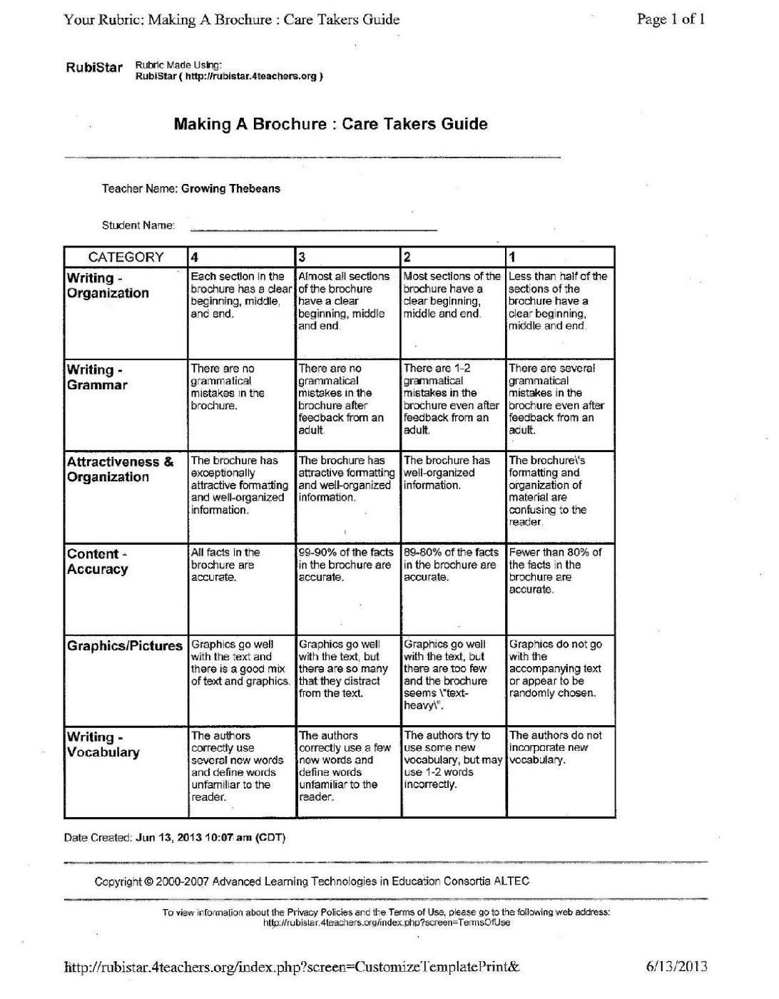

Title | Specialist Extension Lesson (PE)- Baseball
Overview | The learning focus today will be for students to play a traditional Native American game. Students will learn about the game and why it was important to Native Americans.
Standards | WE.4.5.03- strike, toss, catch objects using long-handled implements (e.g., bats, clubs, sticks).  WE.4.6.02- demonstrate one critical element or component for dribbling with feet, striking with racquets, and striking, tossing, catching with long-handled implements (e.g., bats, sticks, clubs).  ELA.4.R.C8.1- Read with sufficient accuracy and fluency to support comprehension. Read on-level text with purpose and understanding.  Read on-level prose and poetry orally with accuracy, appropriate rate, and expression. Use context to confirm or self-correct word recognition and understanding, rereading as necessary.
Materials/Advance Preparation Needed | Materials:  - Baseball bats  - Baseballs  - Mats to be used as bases  - Paper to keep score  - Field and/or outdoor space  - Article about baseball- http://www.iroquoismuseum.org/ve10.htm  Advanced Preparations:  - Make arrangements with physical education teacher to use baseball bats, baseballs, and mats.  - Check weather forecast in order to choose an appropriate day to play baseball.  - Print out baseball sections from the following website page for students to read: http://www.iroquoismuseum.org/ve10.htm
Procedures/Steps:  (Emphasis on students making inquiry, e.g., posing questions/problems and working towards answers and solutions) | Introduction: To begin the lesson, have students recall what they have learned about Native Americans thus far. Next, students will read an article about how baseball was significant to Native Americans.  Lesson: The teacher will go over rules about how to play baseball. Students will be divided into two teams. After creating teams and going over rules, the class will now head outside. Students will play three innings of baseball. The team who scores the most runs will win the game.  Closure: Students will work together to gather materials and return them to the physical education teacher. Once the materials have been returned, the class will return back to the classroom.
Assessment (What will be the evidence of student learning?) | The students will strike a baseball with a bat. The students will toss and catch a baseball. The teacher will have a chart with all students’ names on it. The teacher will note whether or not the students were able to strike a baseball with a bat, toss a baseball, and catch a baseball correctly.

Title | Specialist Extension Lesson (Music)- Grinding Corn
Overview | The learning focus today will be for students to gain an understanding of Native American life and the their connections to food. Students will use rhythms on instruments while playing a passing game.
Standards | MU.O.GM3-5.1.02 Sing or perform an ostinato  MU.O.GM3-5.1.05 Perform rhythmic patterns from notation  MU.O.GM3-5.4.05 Sing songs from global cultures  National Standard 9: Understanding music in relation to history and culture
Materials/ Needed | Materials:  - Story of Grinding Corn.  - Example of baggies filled with corn; red, yellow blue and white  - Variety of 2 beat rhythm card visuals  - Class set of rhythm instruments  - Visual of song  - Solfege scale
Procedures/Steps:  (Emphasis on students making inquiry, e.g., posing questions/problems and working towards answers and solutions) | Introduction: To begin the music lesson, have students recall previous knowledge learned about Native Americans thus far (in the classroom situation). Next, students will read an article about how Native Americans gathered their food and hunted for the necessary items to survive. Students keep simple ostinato and teacher introduces song while sharing the story of Grinding Corn.  Lesson: The teacher will teach students how to play the passing game. Students will make a circle and begin practicing how to pass, and the importance of each student synergizering with one another to complete a common task. After establishing the necessary passing concepts to the steady beat, the class will then compose the ostinatos that will be used during the song. Students will play instruments after they receive the “special passing stone” at the last beat of the song. All students will play instruments to continue working together, as the Native Americans had to do every day in order to survive.  Closure: Students will work together to create ostinatos and return all items to their homes at the conclusion of music class. Once the materials have been returned, the class will line up to return back to the classroom.
Assessment (What will be the evidence of student learning?) | The students will pass to the steady beat. The students will create several ostinatos using a variety of rhythm instruments. The teacher will have a chart with all students’ names on it. The teacher will note whether or not the students were able to pass object to a steady beat, synergize with others and correctly play the rhythm instruments.

Title | Specialist Extension Lesson (Art) - Stepping Stones Spectrum
Overview | This project is a part of an overarching goal which includes a combination of classroom core instruction with utilizing components of the school garden. The garden ill integrate science, language arts, and math to develop and create a school garden/also encompassing art with the spectrum and International connection.
Standards | Content Standard 4: Students describe the function and explore the meaning of specific art objects within varied cultures, times, and places. (Stepping stones will serve a purpose in our garden in a decorative and functional purpose).
Materials/Advance Preparation Needed | Students will engage in inquiry and use scientific data to select plants of the full spectrum to plant an International Palette garden using plants that grow here and are also indigenous to other countries.
Procedures/Steps:  (Emphasis on students making inquiry, e.g., posing questions/problems and working towards answers and solutions) | Students in the classroom will be working on the plant end of this project. I will begin exploration into “Garden Art” including looking at stepping stones from many places. This lesson will follow and connect with the 4th grade garden unit. As students develop research on flowers and vegetables that: A. grows both here in our country and B. follows the colors of the spectrum. This research will generate the imagery for the stones.
Assessment (What will be the evidence of student learning?) | Students will work in groups. Assessment will be based on: 1. Cooperation ideas 2. Technical completion of task.

