Year Long Gardening
4th Grade
Sarah Rummel
James Rye

This unit is composed of four modules: Radish, Winter, Cucumbers, Summer.
About These Units
Origin of These Units. These Garden Project-Based Learning (GPBL) units originate from instruction that North Elementary School (Morgantown, WV) teachers began providing to students in the Spring of 2011. We launched our school gardening efforts through a “Lowe’s Toolbox for Education” grant and in partnership with the College of Education and Human Services at West Virginia University, Monongalia County Extension Office, Monongalia Technical Education Center, and parents of our students.
When and Where it Happens. In all of these units, GPBL takes place inside (the indoor classroom) and outside (the school garden area “outdoor” classroom). Indoors, students learn through the use of grow lights, heat mats, seed germination and growing containers (e.g., EarthBox®), and vermicomposting bins. Instruction is extended to the outdoors through the use of raised garden beds, in which students directly sow seeds and transplant classroom seedlings (see http://www.thevegetablegarden.info/planting-schedules for USDA growing zones). Students also use low tunnels over the raised beds in order to extend the growing season and protect crops from pests. With permission, garden produce may also be served as part of the school lunch. Cafeteria fruit and vegetable clippings/refuse that is not served to the students can be composted and used to amend the garden soil. Learning can continue throughout summer vacation, where students assist their parents who volunteer to take care of the raised beds (watering, mulching, weeding, trellising, etc.). Produce can be vended at a local farmer’s market.
What’s Essential. First and foremost: You need strong support from the principal, custodial and cafeteria staff, and parents as well as expert assistance from the local extension office, including volunteer master gardeners. Here are a few more essentials:
- Integrate GPBL with core curriculum/standards; do not make it an “add-on.” School gardening is an excellent context for application of the Next Generation Science Standards “Science and Engineering” practices and Common Core Mathematics Practices
- Maintain a small library of gardening text and Internet resources.
- Share knowledge and collaborate on projects.
- Install a fence around and a supply shed close to the outdoor garden; have a close-by water supply, > 6 hours sunlight, and high quality soil (consult County Extension).
- Take safety precautions such as:
- know what students are allergic to (including bees) and avoid contact; a bee sting to a person with severe allergy (anaphylaxis) requires immediate medication (usually injection of epinephrine) and medical attention (emergency room);
- wash hands after any gardening activity and keep a first aid kit handy;
- always install tube covers over fluorescent grow lights;
- keep water away from electrical outlets/avoid shock hazards;
- don’t use “chemical” pesticides;
- use plastic versus glass containers and wear goggles when eye damage may occur
- supervise students and provide instructions on the use of garden tools (young learners should not use “adult-size” shovels and hoes).

Supplies Commonly Used In Units. (Identification of any product does NOT constitute endorsement).
- Seeds (not treated) or Bare Roots (for strawberries and certain flowers)
- Pots or Sheets of Cells (in which to germinate seeds) and Trays (in which to hold pots)
- Seed Germination Heat Mat
- Craft Sticks for Marking Type/Locations of seeds/transplants
- Grow Lights (e.g., Hydrofarm® T5 Growlight System or cart with lights and place for seed trays)
- Tube Covers/Protectors (you MUST install tube covers over any fluorescent lights)
- Timers (to automatically turn on and off grow lights)
- Containers/kits for Indoor Gardening (e.g., EarthBox®)
- Low Tunnel (you generally need to make these yourself using greenhouse film and bendable hoops, such as PVC pipe or wire that is secured into the ground or in a wooden frame)
- Potting Soil (WonderSoil® or other suitable products also can be used). Note: Soil for planting should be moist enough to form a clump but not gush water when squeezed).
- Measurement Tools (e.g., rulers, moisture/temperature gauges, scale, graduated cylinder/beakers
- Mulch (e.g., partially composted leaves, organic straw, NOT grass from “treated” lawns)
- Wood/frames (NOT treated) and suitable topsoil (check with County Extension) for raised beds
- Horticultural fleece (garden fleece, Agribon®, Reemay®) for insect barrier and frost protection
- Garden Tools (e.g., trowel, shovel, hoe, rake…a mattock for landscaping to install raised beds)
- Compost to Amend Soil (check with County Extension)
How These GPBL Units are Structured. The graphic on the next page illustrates the components of a GPBL unit as well as how these components are interrelated. For units that require the care of garden plants in summer: Students must prepare a caretakers’ guide. They also write a persuasive letter to parents inviting them to a presentation about the garden and to be caretakers (along with their children) during the summer. Development of the guide, letter, and presentation are excellent ways to integrate English/language arts and art as well as apply the science that they have learned throughout their GPBL.

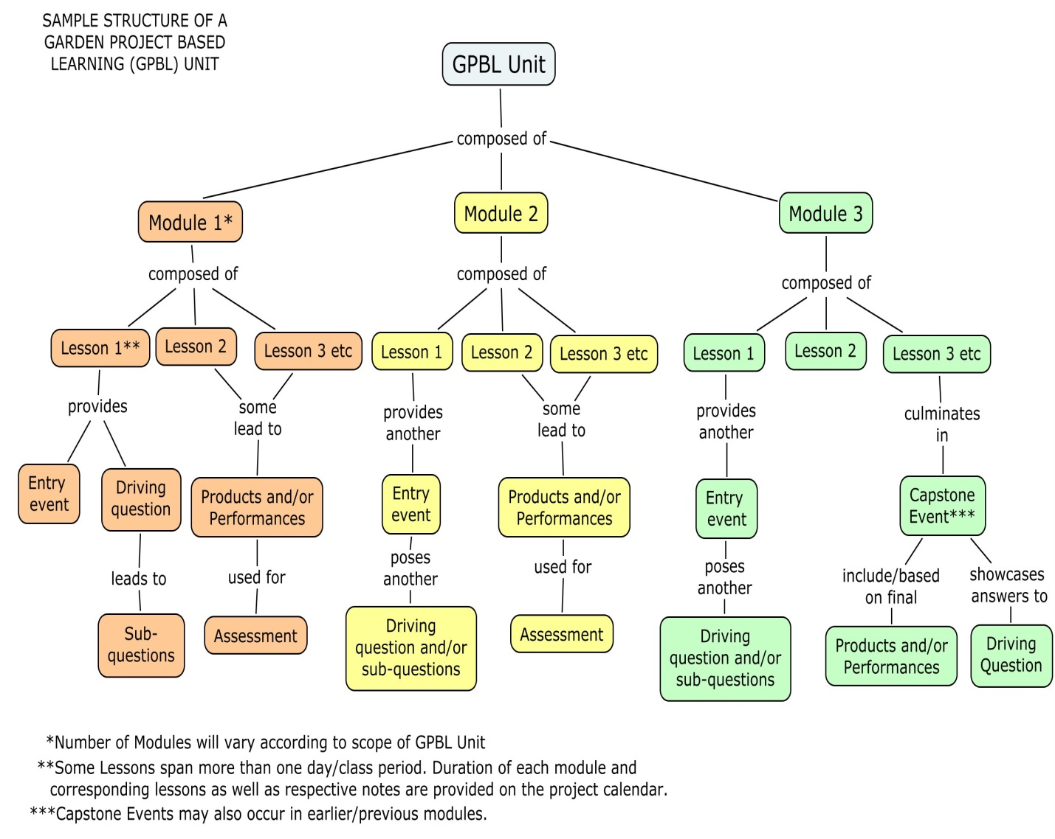
Project Summary
The goal of this Garden Based Project is to be able to plant and produce crops outside all year long. Students jump-start into gardening with planting quick growing radishes in late summer or early fall. Students will learn about the basics of gardening and keeping a science notebook while they grow and harvest radishes. The students will then connect their experience with that of the early colonists of the 13 colonies. Next, students will explore the effect of temperature on gardening. The students will create a scientific test and make a low-tunnel to grow winter crops. Next, the students will learn about the cucurbit family while growing cucumbers inside. The students will explore the differences of direct seeding and transplanting. Students will study the plants in the classroom and compare them to their gardening experiences thus far. As the year comes to a close, the students will use their knowledge of cucumbers and research other cucurbits to determine what they want to plant over the summer. The students will use their research to create a care-takers plan and video to teach their families how to care for the plants during the summer.

Project Driving Question(s)
How can we produce crops outside all year long?

Major Products & Performances in Unit
Module | Group Products | Individual Products
- Radish | Research of root plants  PowerPoint and Presentation  Pickled Radishes | Science notebook  Garden Map  Venn Diagram
- Winter Garden | Data collection  Excel Graph  Setting up an experiment | Notes and observations
- Cucumbers | Setting up an experiment  Pickles | Measuring and data collection  Graph on Excel
- Summer Garden | Research Cucurbits  PowerPoint and Presentation  Caretakers Guide  Video presentation | Persuasive letter

Resources Needed for Unit
Module | Garden Materials | Other Materials
- Radish | * Radish seeds (Rover, Ping Pong, Amethyst)  * Raised Garden Bed | * Science Notebook- 1 per student  * Venn Diagram  * Ruler/yard stick  * graph paper  * area/perimeter worksheet  *computers  * garden books for research  * pickling supplies (see lesson)
- Winter Garden | * Seeds (arugula, corn salad, claytonia)  * Raised Garden Bed  * Temperature gage with at least two receivers (inside low tunnel and out)  * galvanized steel wire (6.5 ft pieces of “standard row cover hoops” are available from FarmTek or Growers Supply),  * greenhouse film (available from any horticultural firm),  * sand bags (or another form of weight). | * measuring tape  * computer  * projector  * Science notebooks -1 per students
- Cucumbers | * Seeds (greenhouse pickling cucumbers)  * Trellis Kit  * String and Wire  * Earthbox  * Heat mat  * Standard Flat (no holes)  * soil  * little plastic pots for seed germination | * Science notebook -1 per students  * computers  * rulers  * pickling supplies (see lesson)  * tape  * measuring tape  * popsicle sticks  * permanent markers
- Summer Garden | *Raised Garden Bed  * Cucurbit Seeds (student selected varieties) | * Graph paper  * Science notebook-1 per student  * chart paper  *computers  * binder  * Markers  * video camera  *paper  * books about plants  *Low Tunnel

