Name of GBPL: The Birds and the Bees…and the Butterflies (Bats, Moths, and Beetles, too.): Exploring pollinators and developing a schoolyard pollinator habitat.
Grade level: 3rd Grade – but can be adapted for any grade level
Author(s): Christina Pizanias
Origin of These Units. These Garden Project-Based Learning (GPBL) units originate from instruction that North Elementary School (Morgantown, WV) teachers began providing to students in the Spring of 2011. We launched our school gardening efforts through a “Lowe’s Toolbox for Education” grant and in partnership with the College of Education and Human Services at West Virginia University, Monongalia County Extension Office, Monongalia Technical Education Center, and parents of our students.
When and Where it Happens. In all of these units, GPBL takes place inside (the indoor classroom) and outside (the school garden area “outdoor” classroom). Indoors, students learn through the use of grow lights, heat mats, seed germination and growing containers (e.g., EarthBox®), and vermicomposting bins. Instruction is extended to the outdoors through the use of raised garden beds, in which students directly sow seeds and transplant classroom seedlings (see http://www.thevegetablegarden.info/planting-schedules for USDA growing zones). Students also use low tunnels over the raised beds in order to extend the growing season and protect crops from pests. With permission, garden produce may also be served as part of the school lunch. Cafeteria fruit and vegetable clippings/refuse that is not served to the students can be composted and used to amend the garden soil. Learning can continue throughout summer vacation, where students assist their parents who volunteer to take care of the raised beds (watering, mulching, weeding, trellising, etc.). Produce can be vended at a local farmer’s market.
What’s Essential. First and foremost: You need strong support from the principal, custodial and cafeteria staff, and parents as well as expert assistance from the local extension office, including volunteer master gardeners. Here are a few more essentials:
- Integrate GPBL with core curriculum/standards; do not make it an “add-on.” School gardening is an excellent context for application of the Next Generation Science Standards “Science and Engineering” practices and Common Core Mathematics Practices
- Maintain a small library of gardening text and Internet resources.
- Share knowledge and collaborate on projects.
- Install a fence around and a supply shed close to the outdoor garden; have a close-by water supply, > 6 hours sunlight, and high quality soil (consult County Extension).
- Take safety precautions such as:
  - know what students are allergic to (including bees) and avoid contact; a bee sting to a person with severe allergy (anaphylaxis) requires immediate medication (usually injection of epinephrine) and medical attention (emergency room);
  - wash hands after any gardening activity and keep a first aid kit handy;
  - always install tube covers over fluorescent grow lights;
  - keep water away from electrical outlets/avoid shock hazards;
  - don’t use “chemical” pesticides;
  - use plastic versus glass containers and wear goggles when eye damage may occur
  - supervise students and provide instructions on the use of garden tools (young learners should not use “adult-size” shovels and hoes).

Supplies Commonly Used In Units. (Identification of any product does NOT constitute endorsement).
- Seeds (not treated) or Bare Roots (for strawberries and certain flowers)
- Pots or Sheets of Cells (in which to germinate seeds) and Trays (in which to hold pots)
- Seed Germination Heat Mat
- Craft Sticks for Marking Type/Locations of seeds/transplants
- Grow Lights (e.g., Hydrofarm® T5 Growlight System or cart with lights and place for seed trays)
- Tube Covers/Protectors (you MUST install tube covers over any fluorescent lights)
- Timers (to automatically turn on and off grow lights)
- Containers/kits for Indoor Gardening (e.g., EarthBox®)
- Low Tunnel (you generally need to make these yourself using greenhouse film and bendable hoops, such as PVC pipe or wire that is secured into the ground or in a wooden frame)
- Potting Soil (WonderSoil® or other suitable products also can be used). Note: Soil for planting should be moist enough to form a clump but not gush water when squeezed).
- Measurement Tools (e.g., rulers, moisture/temperature gauges, scale, graduated cylinder/beakers
- Mulch (e.g., partially composted leaves, organic straw, NOT grass from “treated” lawns)
- Wood/frames (NOT treated) and suitable topsoil (check with County Extension) for raised beds
- Horticultural fleece (garden fleece, Agribon®, Reemay®) for insect barrier and frost protection
- Garden Tools (e.g., trowel, shovel, hoe, rake…a mattock for landscaping to install raised beds)
- Compost to Amend Soil (check with County Extension)
How These GPBL Units are Structured. The graphic on the next page illustrates the components of a GPBL unit as well as how these components are interrelated. For units that require the care of garden plants in summer: Students must prepare a caretakers’ guide. They also write a persuasive letter to parents inviting them to a presentation about the garden and to be caretakers (along with their children) during the summer. Development of the guide, letter, and presentation are excellent ways to integrate English/language arts and art as well as apply the science that they have learned throughout their GPBL.
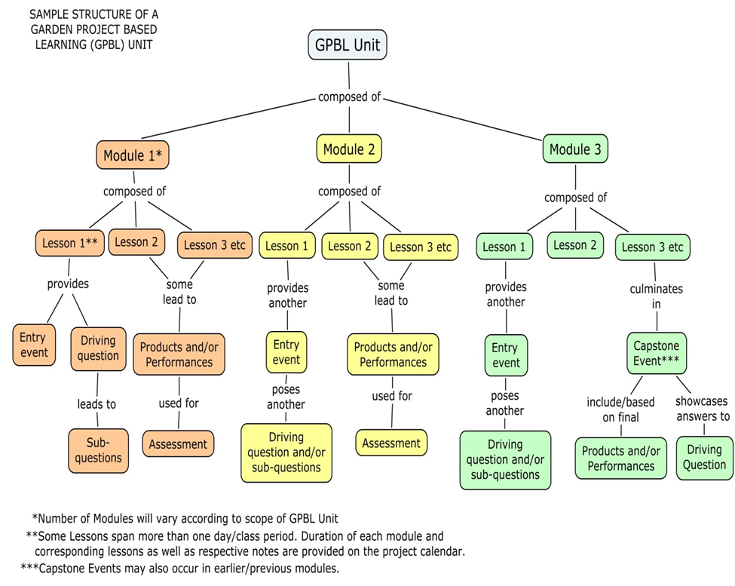

Date Developed: August, 2014
Project Idea/Summary:
This project focuses on the great importance of pollinators in our environment and especially as it pertains to our food supply. One-third of the food we consume is a direct result of pollination. Yes, pollinators including bats, hummingbirds, and insects such as bees, butterflies, and beetles collectively are responsible for pollinating 33% of the foods we enjoy! Pollination is perhaps one of the most “taken for granted” of ecosystem services, in which pollinators transfer pollen from the anther to the stigma of flowers, in turn producing a fruit with seeds. Most elementary students do not know that bees and other pollinators are the reason that we are able to enjoy fruits, such as apples, blueberries, and melons as well as cucumbers and squash.
Students will learn about the decline of some pollinators and create a pollinator-friendly habitat.
Students will be able to observe the interactions between pollinators and plants and better understand the connection between pollinators, plants, and the food we eat.
Honey bees, certain bumblebees, and Monarch Butterflies are being negatively impacted by pesticides and habitat destruction; your pollinator garden will provide them with pollen/nectar sources, nesting boxes, water and cover.
Community outreach and education can be incorporated through the celebration of National Pollinator Week in June. An added benefit of this project is that it will enhance the pollination of edible crops in your school garden.
Standards Targeted:
Standards: | Module1 | Module2
Science
3-LS1-1 Develop models to describe that organisms have unique and diverse life cycles but all have in common birth, growth, reproduction, and death. | X
3-LS4-3 Construct an argument with evidence that in a particular habitat some organisms can survive well, some survive less well, and some cannot survive at all. |  | X
3-LS4-4 Make a claim about the merit of a solution to a problem caused when the environment changes and the types of plants and animals that live there may change. |  | X
Science and Engineering Practices:
- Asking questions and defining problems. | X | X
- Developing and using models. | X
- Using mathematics and computational thinking. | X
- Constructing explanations and designing solutions. |  | X
- Engaging in argument from evidence. |  | X
- Obtaining, evaluating and communicating information | X | X
English Language Arts
Reading
ELA.3R.C1.4 Ask and answer questions to demonstrate understanding of an informational text, referring explicitly to the text as the basis for the answers. | X
ELA.3R.C1.5 Determine the main idea of an informational text; recount the details and explain how they support the main idea. | X
ELA.3.R.C1.6 Describe the relationship between a series of historical events, scientific ideas or concepts or steps in technical procedures in an informational text, using language that pertains to time, sequence and cause/effect. | X
ELA.3.R.C2.4 Determine the meaning of general academic and domain-specific words and phrases in an informational text relevant to a grade 3 topic or subject area. | X | X
ELA.3.R.C3.3 Use information gained from illustrations (e.g., maps and photographs) and words in an informational text to demonstrate understanding of the text (e.g., where, when, why, and how key events occur). |  | X
ELA.3.R.C3.4 Describe the logical connection between particular sentences and paragraphs in an informational text (e.g., comparison, cause/effect, first/second/third in a sequence). | X
Writing
ELA.3.W.C9.2 Write informative/explanatory texts to examine a topic and convey ideas and information clearly | X | X
Speaking and Listening
ELA.3.SL.C13.1 Engage effectively in a range of collaborative discussions (one-on-one, in groups, teacher-led) with diverse partners on grade 3 topics and texts, building on others’ ideas and expressing their own clearly. | X | X
ELA.3.SL.C13.2 Determine the main ideas and supporting details of a text read aloud or information presented in diverse media and formats, including visually, quantitatively and orally. | X | X
ELA.3.SL.C13.3 Ask and answer questions about information from a speaker, offering appropriate elaboration and detail. |  | X
ELA.3.SL.C14.3 Speak in complete sentences when appropriate to task and situation in order to provide requested detail or clarification. |  | X
Math
M.3.MD.4 Generate measurement data by measuring lengths using rulers marked with halves and fourths of an inch and show the data by making a line plot, where the horizontal scale is marked off in appropriate units—whole numbers, halves or quarters. | X
Wellness
WE.3.4.01 Describe the food guide pyramid and its value to personal health, recognizing that food provides energy and nutrients for growth and development. |  | X
WE.3.4.02 Record and compare food choices based on recommended serving sizes. |  | X
WE.3.4.09 Assess factors (e.g. food choices, physical activity, genetic) that contribute to achieving and maintaining a healthy body. |  | X
21st Century Skills:
21C.S.3-4.2 The student will demonstrate the ability to explore and develop new ideas, to intentionally apply sound reasoning processes and to frame, analyze and solve complex problems using appropriate technology tools. | X

Project Driving Question:
- Of what value are pollinators to an ecosystem?
Sub-Driving Questions:
- Of what value are pollinators to humans?
- Of what value are pollinators to our garden?
- What types of pollinators can we attract?
- How can we attract pollinators?
- What do pollinators need to survive?
- Why are pollinators declining?
- How can we help pollinators?
Resources:
Books:
Burris, J. & Richards, W. (2006). The life cycle of butterflies: From egg to maturity, a visual guide to 23 common garden butterflies. North Adams, MA: Storey Publishing.
Hannemann, M., Hulse, P., Johnson, B., Kurland, B., & Patterson, T. (2011). Gardening with children. Brooklyn, NY: Brooklyn Botanic Garden.
Helbrough, E. (2006). How flowers grow. Tulsa, OK: EDC Publishing.
Hood, S. (1998). National Audubon Society first field guide: Wildflowers. New York, NY: Scholastic, Inc.
Lavelle, C. & Lavelle, M. (2010). The best plants to attract and keep wildlife in your garden: Making a backyard home for animals, birds & insects. London SE: Southwater.
Leslie, C.W., & Roth, C.E. (2000). Keeping a nature journal: Discover a whole new way of seeing the world around you. North Adams, MA: Storey Publishing.
Mader, E., Spepherd, M., Vaughan, M., Black, S. H., & LeBuhn, G. (2011). The Xerces Society guide: Attracting native pollinators: Protecting North America’s bees and butterflies. North Adams, MA: Storey Publishing.
Publications:
Moisset, B. & Buchmans, S. (2011). Bee basics: An introduction to our native bees. USDA Forest Service & Pollinator Partnership Publication.
Websites/links:
Ecological Society of America - “Pollination Toolkit” created/reviewed by scientists – Great Resource! http://www.esa.org/ecoservices/poll/body.poll.intr.html
Butterflies and Butterfly Gardening in West Virginia, WVU Extension Service: http://www.wvu.edu/~agexten/wildlife/butterfl.htm
Butterfly Gardening, WV Department of Natural Resources: http://www.wvdnr.gov/Wildlife/ButterflyGarden.shtm
Forest Service – USDA – Pollinator Resources: http://www.fs.fed.us/wildflowers/pollinators/index.shtml
Common Wildflowers in WV, WVU Extension: http://www.wvu.edu/~agexten/hortcult/flowers/wldflwrs.htm#Thistle
Agriculture Research Service – USDA: Building a Nesting Block: http://www.ars.usda.gov/Services/docs.htm?docid=10743
Nests for Native Bees: http://www.xerces.org/wp-content/uploads/2008/11/nests_for_native_bees_fact_sheet_xerces_society.pdf
National Wildlife Federation - Garden for Wildlife – Certify your schoolyard habitat: http://www.nwf.org/How-to-Help/Garden-for-Wildlife/Schoolyard-Habitats/Certify-Your-Schoolyard.aspx
Wild in the Woods – Pollination Partners: http://www.dgif.virginia.gov/habitat/wild-in-the-woods/pollination-partners.pdf
Pollinator Field Journal (1/student): http://www.gardeningwithkids.org/pollinator-field-journal.html
(2007). North American Pollinator Protection Campaign Pollinator Curriculum: Nature’s partners: Pollinators, plants, and you. http://www.nrcs.usda.gov/Internet/FSE_PLANTMATERIALS/publications/nypmctn11164.pdf
“Attracting Pollinators to Your Garden Using Native Plants” U.S. Forest Service http://www.fs.fed.us/wildflowers/pollinators/documents/AttractingPollinatorsEasternUS_V1.pdf
“Attracting Pollinators to Your Garden” U.S. Fish and Wildlife Service http://www.fws.gov/pollinators/pdfs/PollinatorBookletFinalrevWeb.pdf
PowerPoint: Pollinator-Friendly Plants for the Northeast United States – USDA/NRCS: http://www.nrcs.usda.gov/Internet/FSE_PLANTMATERIALS/publications/nypmctn11164.pdf
PowerPoint: The Birds and the Bees…and the Beetles –Why we should care about pollinators. – U.S. Fish & Wildlife Service: http://www.fws.gov/pollinators/pollinatorpages/outreach.html

PROJECT OUTLINE/SCOPE & SEQUENCE:
Late Summer/Beginning of the School Year
- Field trip opportunity: Visit botanical gardens and existing pollinator gardens.
- Outdoor observations while plants are still in bloom (thru fall)
- Bee nesting boxes can be placed so they will be occupied over winter
Fall
- Observations can continue
- Garden bed planning and design
- Fall bare roots and bulbs can be planting for following growing season
Fall/Early Winter/Spring
- Garden bed planning and design
- Fall bare roots and bulbs can be planting for following growing season
Late Winter/Spring
- Plants can be started indoors from seed
- Organize and plan for Pollinator Week
- Build bee nesting boxes
Spring
- Pollinator bed is prepped and ready
- Plants can be started indoors from seed
- Organize and plan for Pollinator Week
- Build bee nesting boxes
After last frost
- Garden can be planted
June
- National Pollinator Week

Table of Contents
Module 1
- Lesson 1 – What’s the Pollinator Problem?
Students will read two articles highlighting the decline of pollinators and will discuss the issues presented in the articles and identify the problem surrounding pollinators and why people should be concerned.
- Lesson 2 – Science Notebook
Students will learn the importance of a science notebook. They create their own science notebook with a table of contents.
- Lesson 3 – Meet the pollinators.
Student will be introduced to various insect and animal pollinators. Students will draw diagrams of specimens in their science notebook. Students will make models of various pollinators.
- Lesson 4 – What is pollination?
Students will learn about the different parts of a flower and dissect various types of flowers in order to identify the different reproductive parts. Students will draw diagram in their science notebooks. Understanding the function of the parts of a flower leads students to understand the role of pollinators in plant fruit production.
Students will make models of flowers using various materials.

Module 2 – Gardening for pollinators
- Lesson 1 – My Plate - Students will become familiar with the USDA My Plate icon and the recommendations for planning a healthy meal. Students will plan meals and then analyze the meals to determine what foods are dependent on pollinators. Students will draw conclusions on how declining pollinators can affect food availability.
- Lesson 2 – Visiting a Pollinator Garden - A Field Trip
Students will visit an established garden and meet with professionals to make observations and have some question & answer time with experts.
- Lesson 3 – Designing a garden to attract pollinators - Students will revisit the issue of declining pollinator and the effect on crops. Students will brainstorm possible solutions. Students can be guided to the development of a school yard pollinator habitat to attract pollinators by providing them with food and shelter.

Extension Activities – Community Education
- Create Informational presentation for school, parents, and public.
- Organizing community outreach for Pollinator Week
- Art in the Garden – Pollinator Sculpture

