From Jack B. Littles to
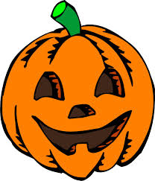
Jack-o-Lanterns
(Math with Pumpkins)

Crease

Vocabulary

Crease - ___________________________________________

___________________________________________________

Estimate- ___________________________________________

___________________________________________________

Vertical - ___________________________________________

___________________________________________________

Horizontal - ___________________________________________

_____________________________________________________

I estimate that my pumpkin has _____________ creases.

My pumpkin really has ___________ creases.

Crease

Crease - A ______________ is the line that runs _____________ along the pumpkin.

Estimate- An _________________ guess.

Vertical - Positioned _____ and ________ as opposed to _______

to __________

Horizontal - Positioned __________ to __________ as opposed to

_________ and _________.

I estimate that my pumpkin has _____________ creases.

My pumpkin really has ___________ creases.

Circumference
Vocabulary

Circumference - __________________________________________

______________________________________________________

Conversions- __________________________________________

______________________________________________________

Inches - ____________________________________________

___________________________________________________

Centimeters - __________________________________________

______________________________________________________

- I estimate the circumference of my pumpkin will be _____________ inches.
- My pumpkin has a circumference of ____________ inches.

- Convert your measurement in inches to centimeters. SHOW YOUR WORK! To convert inches to centimeters, I must multiply the total inches by 2.54
- _____in. x 2.54 = _____cm.
- The circumference of my pumpkin is __________ centimeters.
- *Measure the circumference of your pumpkin with a piece of yarn and glue to a piece of construction paper in the form of a circle.

Circumference
Vocabulary

Circumference - The ___________ all the way around the edge of a

__________.

Conversions- To __________ in form.

Inches - A unit of linear _________ equal to one twelfth of a foot.

Centimeters - A unit of ________ equal to one hundredth of a meter

- I estimate the circumference of my pumpkin will be _____________ inches.
- My pumpkin has a circumference of ____________ inches.

- Convert your measurement in inches to centimeters. SHOW YOUR WORK! To convert inches to centimeters, I must multiply the total inches by 2.54
- _____in. x 2.54 = _____cm.
- The circumference of my pumpkin is __________ centimeters.
- *Measure the circumference of your pumpkin with a piece of yarn and glue to a piece of construction paper in the form of a circle.

Diameter
Vocabulary

Diameter- __________________________________________

______________________________________________________

Center point- __________________________________________

______________________________________________________

- I estimate that my pumpkin will have a diameter of ____________ inches
- Get a new piece of yarn and your circle paper.
- Hold the new yarn on one edge of the circle, run it through the center point to the opposite edge of the circle. Cut the yarn.
- To measure the diameter of your pumpkin in inches measure your new piece of yarn.
- My pumpkin has a diameter of __________.
- Convert your diameter in inches to centimeters. SHOW YOUR WORK! To convert inches to centimeters, multiply the total inches by 2.54.
          - _________in. x 2.54 = __________cm.
- The diameter of my pumpkin is __________ centimeters.

Diameter

Vocabulary

Diameter- A line that cuts a ______________directly in ___________.

Center point- The _________of a circle.

- I estimate that my pumpkin will have a diameter of ____________ inches
- Get a new piece of yarn and your circle paper.
- Hold the new yarn on one edge of the circle, run it through the center point to the opposite edge of the circle. Cut the yarn.
- To measure the diameter of your pumpkin in inches measure your new piece of yarn.
- My pumpkin has a diameter of __________.
- Convert your diameter in inches to centimeters. SHOW YOUR WORK! To convert inches to centimeters, multiply the total inches by 2.54.
          - _________in. x 2.54 = __________cm.
- The diameter of my pumpkin is __________ centimeters.

Radius

Vocabulary

Radius- __________________________________________

______________________________________________________

- I estimate that my pumpkin will have a radius of ____________ inches
- Hold a new piece yarn on one edge of the circle, run it through the center point and cut the yarn.
- Measure this piece of yarn using a ruler.
- My pumpkin has a radius of __________.
- Convert your radius in inches to centimeters. SHOW YOUR WORK! To convert inches to centimeters, multiply the total inches by 2.54.
          - _________in. x 2.54 = __________cm.
- The radius of my pumpkin is __________ centimeters.

Radius
Vocabulary

Radius- Half the distance of the _____________

- I estimate that my pumpkin will have a radius of ____________ inches
- Hold a new piece yarn on one edge of the circle, run it through the center point and cut the yarn.
- Measure this piece of yarn using a ruler.
- My pumpkin has a radius of __________.
- Convert your radius in inches to centimeters. SHOW YOUR WORK! To convert inches to centimeters, multiply the total inches by 2.54.
          - _________in. x 2.54 = __________cm.
- The radius of my pumpkin is __________ centimeters.

Weight
Vocabulary

Weight- __________________________________________

______________________________________________________

Pounds- __________________________________________

______________________________________________________

Grams- __________________________________________

______________________________________________________

- I estimate that my pumpkin weighs __________ pounds
- Place your pumpkin on the center of the scale
- Record the weight of your pumpkin in pounds (lbs)
- Convert pounds into grams. SHOW YOUR WORK!
  - To convert pounds into grams, multiply ________lbs x 454.
  - ________lbs x 454 = __________ grams

- My pumpkin weighs _________ grams

Weight

Vocabulary

Weight- The _______________ of a thing

Pounds-a unit of ________ in general use equal to 16 oz (about the

size of a _____________)

Grams-a _________ unit of mass equal to one thousandth of a kilogram (about the size of a _______________)

- Iestimate that my pumpkin weighs __________ pounds
- Place your pumpkin on the center of the scale
- Record the weight of your pumpkin in pounds (lbs)
- Convert pounds into grams. SHOW YOUR WORK!
  - To convert pounds into grams, multiply ________lbs x 454.
  - ________lbs x 454 = __________ grams

- My pumpkin weighs _________ grams

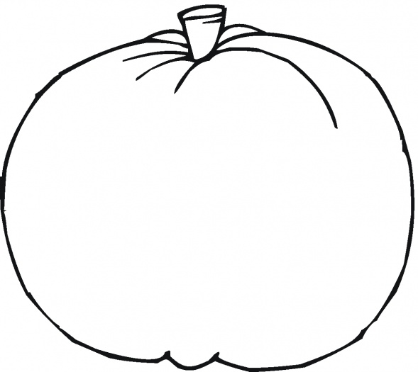
Design your Jack-o-Lantern!

Jack B Little to Jack-o-Lanterns!

- Use your design page to carve your pumpkin.
- Upon completion, place your jack-o-lantern on the scale.
- Record the weight of your jack-o-lantern in pounds.
- My jack-o-lantern weighs __________ pounds.
- Convert pounds into grams. SHOW YOUR WORK! To convert pounds to grams, multiply _________lbs x 454
              - ________lbs x 454 = __________grams

- My jack-o-lantern weighs ________ grams.
- The difference in weight between my pumpkin and jack-o-lantern is
- __________lbs
- or __________grams

Seeds

- I estimate that my pumpkin has __________ seeds.
- Count the number of seeds in your pumpkin.
- My pumpkin actually has _________ seeds.
- I estimate my pumpkin seeds weigh __________ grams.
- Use the scale to weigh your seeds.
- My pumpkin seeds actually weigh _________ grams.

Vocabulary

Crease - A crease is the line that runs vertically along the pumpkin

Estimate - An educated guess

Vertical - Positioned up and down as opposed to side to side

Horizontal - Positioned side to side as opposed to up and down.

Circumference - The length all the way around the edge of a circle.

Conversion - To change in form

Centimeters - A unit of length equal to one hundredth of a meter

Inches - A unit of linear measure that is equal to one twelfth of a foot

Diameter - A line the cuts a circle directly in half

Center point - The center of a circle.

Radius - Half the distance of the diameter

Weight - the heaviness of a thing

Pounds - a unit of weight in general use equal to 16 oz (about the size of a loaf of bread or a football)

Gram - a metric unit of mass equal to one thousandth of a kilogram (about the size of a paperclip)

